Appendix：

New and Old Namplates of "Shuangling" Hot Rolled Ribbed Bars and “Xianggang”Hot Rolled Plain Bars

New Namplate of "Shuangling" Hot Rolled Ribbed Bars:

The front of new nameplate The back of new nameplate
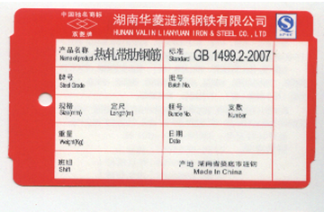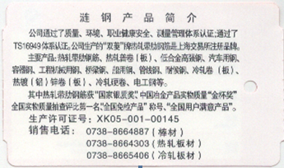

The Old Namplate of "Shuangling" Hot Rolled Ribbed Bars:

The front of the old nameplate The back of the old nameplate

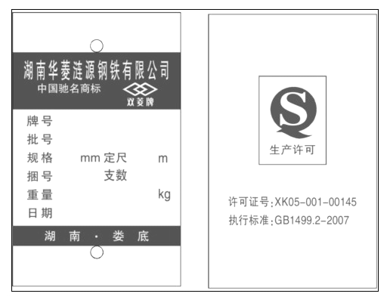

New Namplate of "Xianggang" Hot Rolled Plain Bars:
The front of new nameplate The back of new nameplate
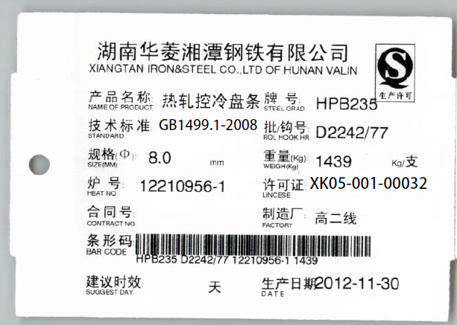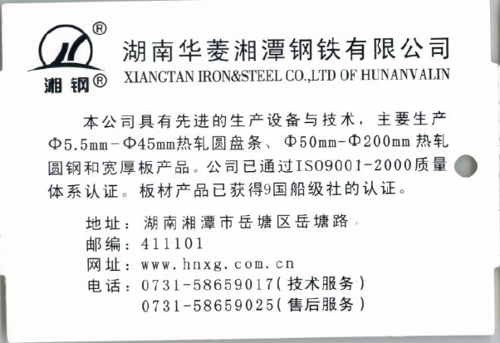

The Old Namplate of "Xianggang" Hot Rolled Plain Bars:
The front of old nameplate The back of old nameplate
