Notification on Approval of Registration of “Jing Ye” Rebar Produced by Hebei Iron & Steel Group Jing Ye Steel Co. Ltd.
Updated: Dec. 27, 2012
S.Q.P.F. ［2012］No.85
Hebei Iron & Steel Group Jingye Steel Co. Ltd.,
We have received your company's Report on Application for Registration of Steel by Hebei Iron & Steel Group Jing Ye Steel Co. Ltd. and relevant documents. In accordance with relevant regulations, specifically the Regulations of Shanghai Futures Exchange on Registration of Steel for Futures Delivery, your company's " Jing Ye" steel rebar complies with all specifications as prescribed in the Exchange's standard contract for rebar after our on-site inspection of registration, sampling and assaying. Upon our consideration, your company is hereby notified of the following:
Ⅰ. Your company has been given the approval to register “Jing Ye” rebar with the Exchange.
Ⅱ. Since the release of this Notification, the abovementioned product can be used for the performance delivery of the Exchange’s standard contract for rebar. The product-specific descriptions are as below:
Producer: Hebei Iron & Steel Group Jing Ye Steel Co. Ltd.
Product: Steel for reinforced concrete: Hot rolled ribbed bars
Registered trademark: Jing Ye
Place of origin：Pingshan, Hebei Province
Product logo:（as shown in figure）
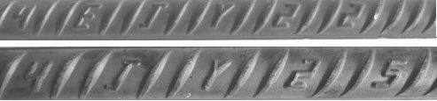
The front of nameplate：
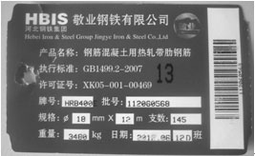
The back of nameplate:
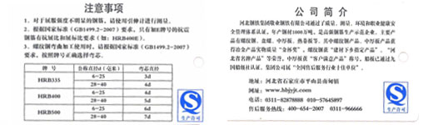
Product specifications：
Place of Origin | Brand name | Diameter  (mm) | Length  (m) | Piece per Bundle | Weight of Bundle  (Kg) | Bundle per Lot
Pingshan, Hebei Province | HRB400 | 16 | 9 | 220 | 3128 | 96
Pingshan, Hebei Province | HRB400 | 16 | 12 | 185 | 3508 | 86
Pingshan, Hebei Province | HRB400 | 18 | 9 | 180 | 3240 | 93
Pingshan, Hebei Province | HRB400 | 18 | 12 | 145 | 3480 | 86
Pingshan, Hebei Province | HRB400 | 20 | 9 | 140 | 3112 | 96
Pingshan, Hebei Province | HRB400 | 20 | 12 | 120 | 3557 | 84
Pingshan, Hebei Province | HRB400 | 22 | 9 | 120 | 3218 | 93
Pingshan, Hebei Province | HRB400 | 22 | 12 | 100 | 3576 | 84
Pingshan, Hebei Province | HRB400 | 25 | 9 | 90 | 3119 | 96
Pingshan, Hebei Province | HRB400 | 25 | 12 | 75 | 3465 | 87
Packaging: firmly and evenly bundled up with not less than four loops of steel straps or wire rod
Sstandard: GB1499.2-2007
This Notification is specially issued.
Appendix: Registered Trademark and Packaging Standard of Rebar of Shanghai Futures Exchange

