Attachment:

New and Current Nameplates of “ZENITH” Hot rolled Ribbed Bars

New Nameplate of “ZENITH” Hot rolled Ribbed Bars:

Front of New Nameplate   | Back of New Nameplate  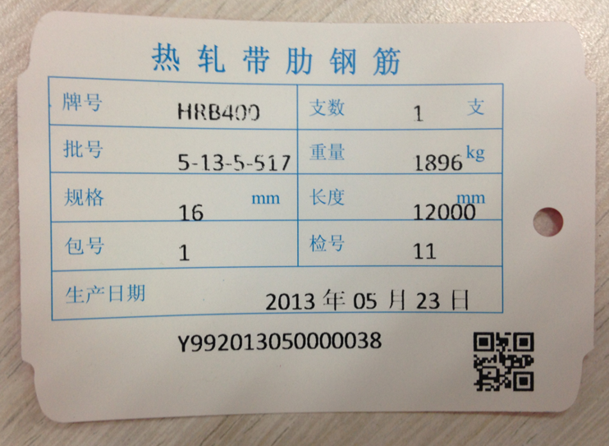

Current Nameplate of “ZENITH” Hot rolled Ribbed Bars:

