Appendix：
New and Existing Nameplate of “Xinxing” Hot-rolled Ribbed Bars
New Nameplate of “Xinxing” Hot-rolled Ribbed Bars（Wuan, Hebei Province）
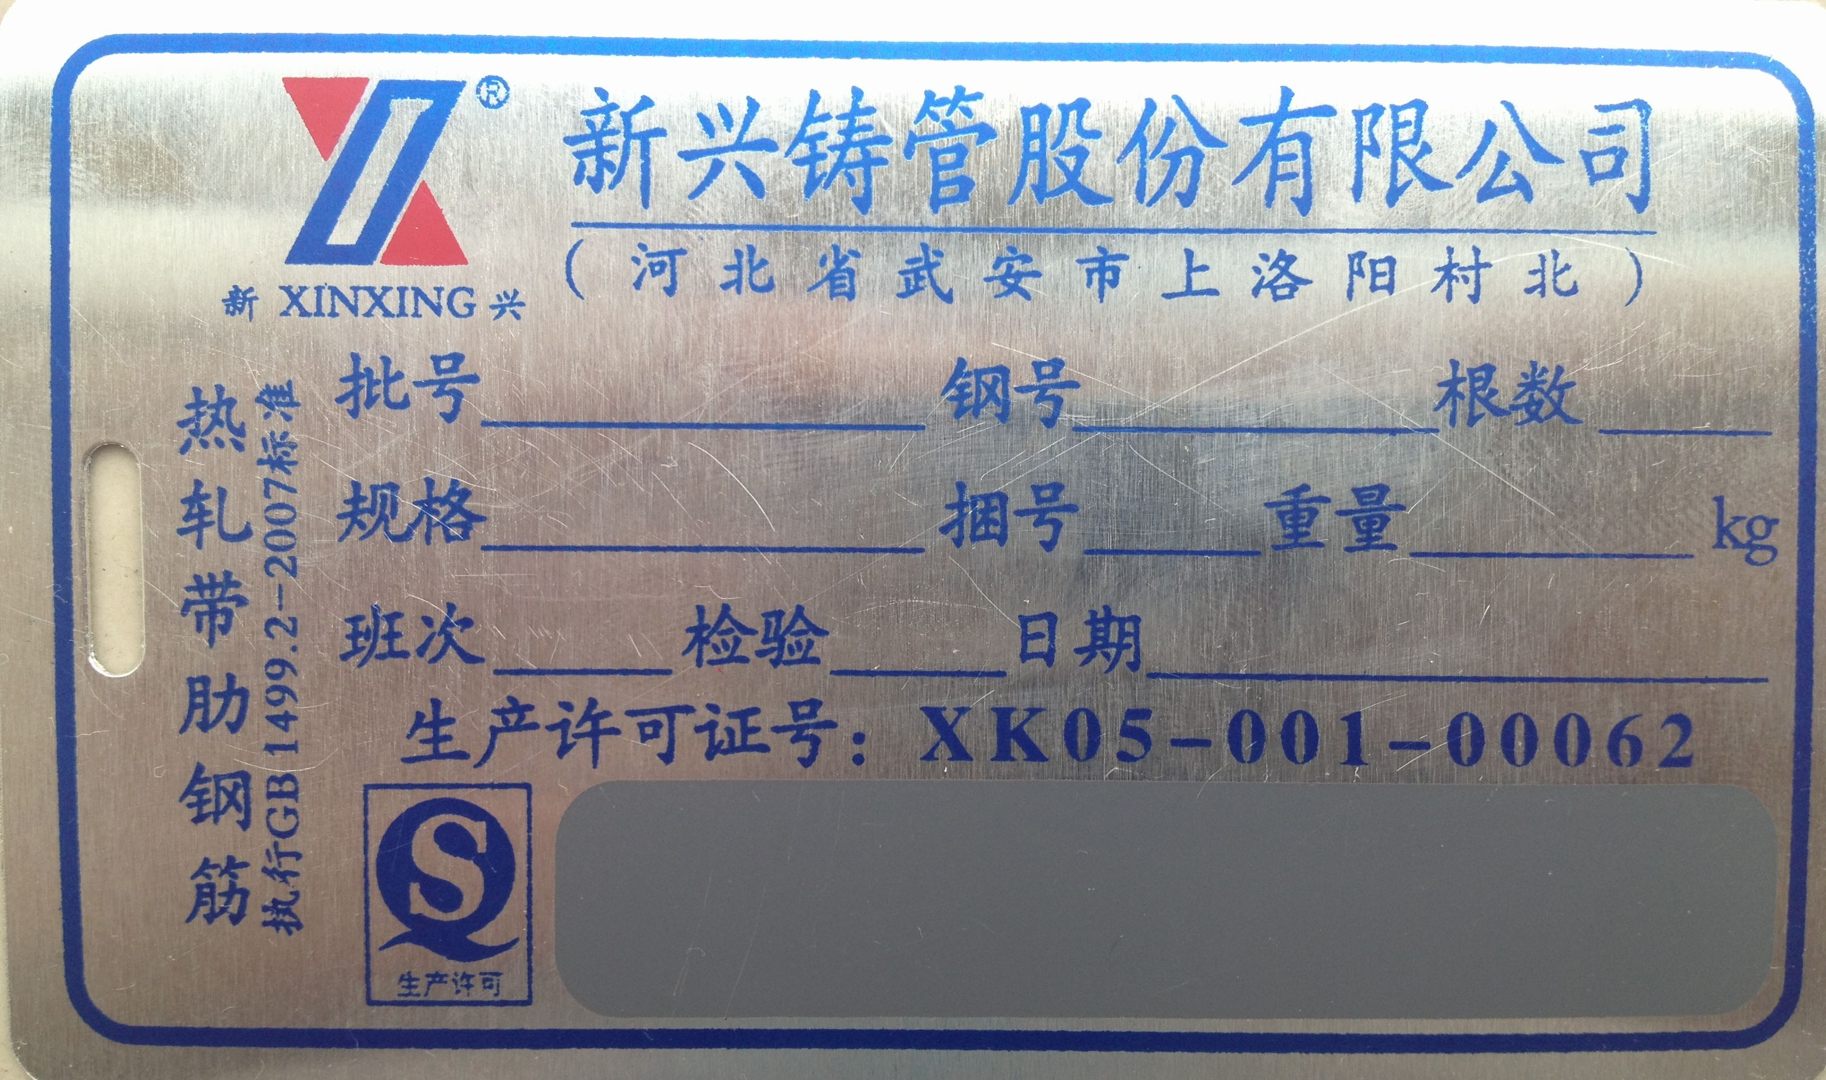

New Nameplate of “Xinxing” Hot-rolled Ribbed Bars（Wuhu, Anhui Province）
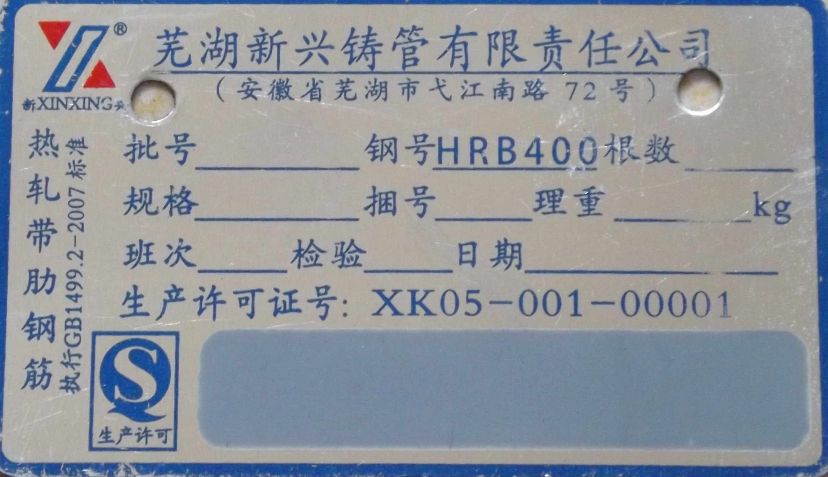

Existing Nameplate of “Xinxing” Hot-rolled Ribbed Bars（Wuan, Hebei Province） 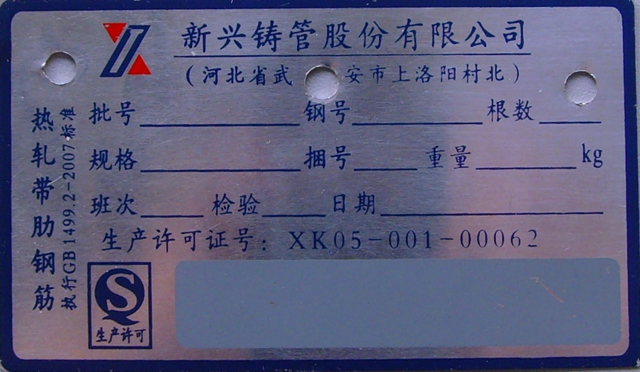

Existing Nameplate of “Xinxing” Hot-rolled Ribbed Bars（Wuhu, Anhui Province）
