Appendix

New and Existing Nameplates of “Jigang” and “Laigang” Hot-rolled Ribbed Bars

New Nameplate of “Jigang” Hot-rolled Ribbed Bars:
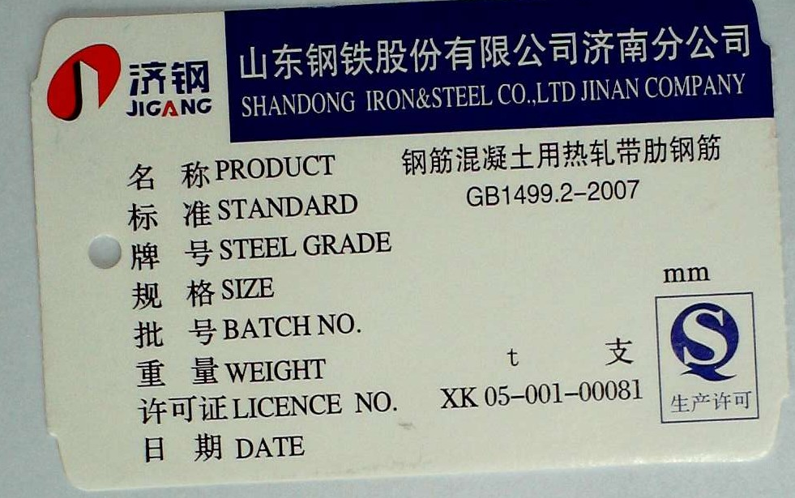

Existing Nameplate of “Jigang” Hot-rolled Ribbed Bars:
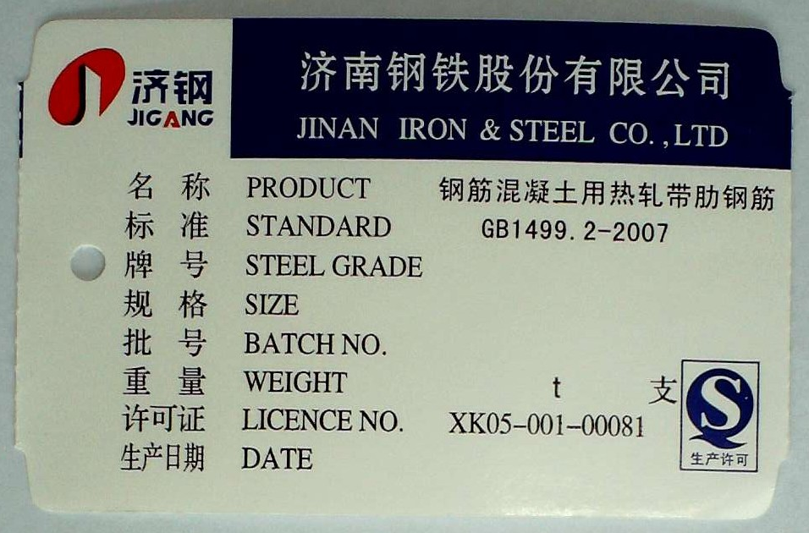

New Nameplate of “Laigang” Hot-rolled Ribbed Bars:
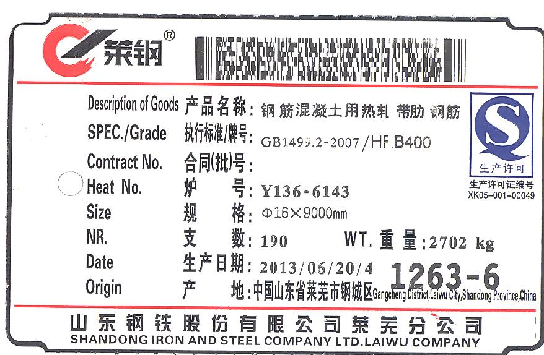

Existing Nameplate of “Laigang” Hot-rolled Ribbed Bars:
