Appendix

New and Existing Nameplate of “Shagang” Hot-rolled Ribbed Bars and Hot-rolled Plain Bars

New Nameplate of “Shagang” Hot-rolled Ribbed Bars：
The Front of New Nameplate  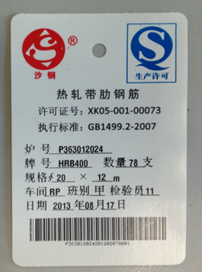 | The Back of New Nameplate  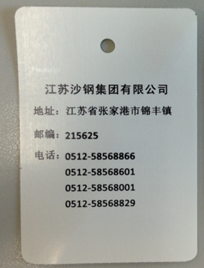
Nameplate Description:
Dimension: 60*90mm; bore diameter: 5mm; bore center is 10mm away from its edge; background color of this nameplate is white, with Shagang’s logo in red, production license logo in blue and the rest printed characters in black.
Existing Nameplate of “Shagang” Hot-rolled Ribbed Bars：
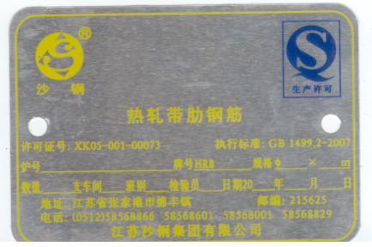
New Nameplate of “Shagang” Hot-rolled Plain Bars：

The Front of New Nameplate  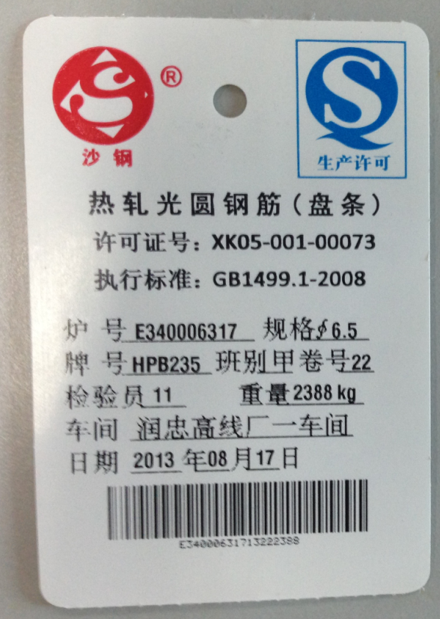 | The Back of New Nameplate

Nameplate Description:
Dimension: 60*90mm; bore diameter: 5mm; bore center is 10mm away from its edge; background color of this nameplate is white, with Shagang’s logo in red, production license logo in blue and the rest printed characters in black.

Existing Nameplate of “Shagang” Hot-rolled Plain Bars：


