Appendix 2: The Way of Watching the Training Video
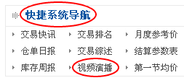
快捷系统导航：Shortcut System Navigator
视频演播：Video Studio

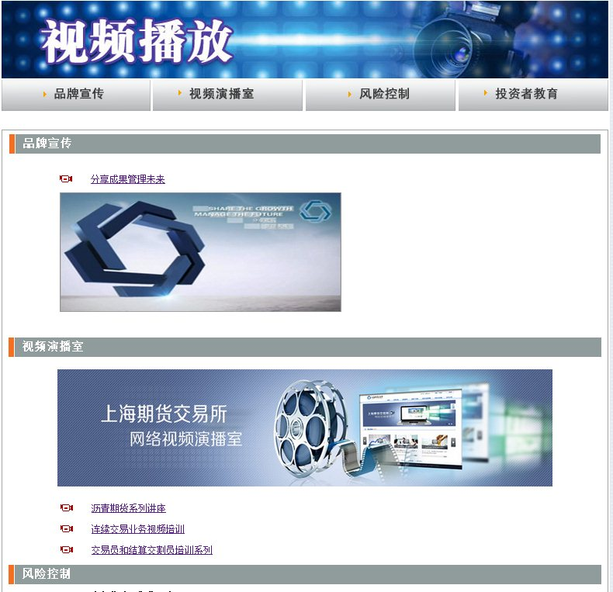

交易员和结算交割员培训系列： Series of Training for Traders and Settlement & Delivery Clerk”

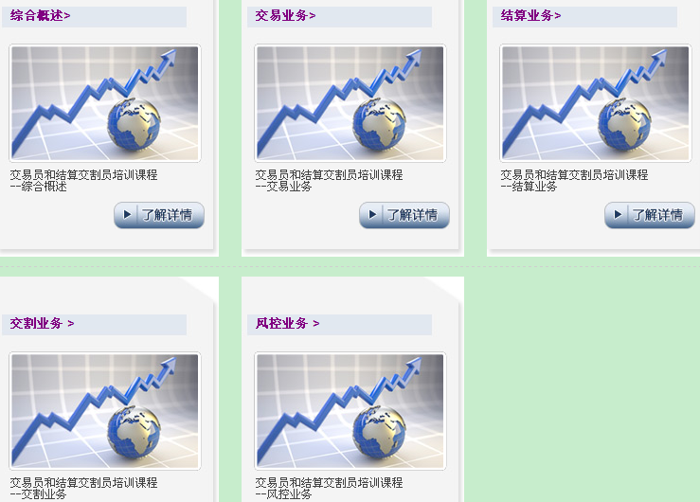

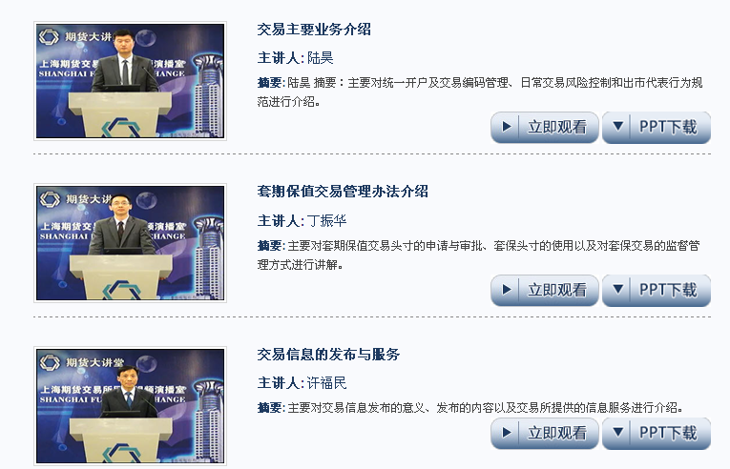

连续交易业务视频培训： Video Training for Continuous Trading Business

