Appendix

New and Old Product Nameplates of “Yanshan” Hot Rolled Ribbed Bars and Hot Rolled Plain Bars and New and Old Surface Markers of Hot Rolled Ribbed Bars Produced in Handan, Hebei Province

New Nameplate of “Yanshan” Hot Rolled Ribbed Bars produced in Chengde, Hebei Province:
Front of New Nameplate:  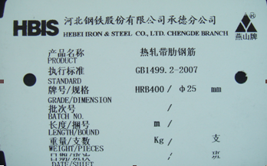 | Back of New Nameplate:  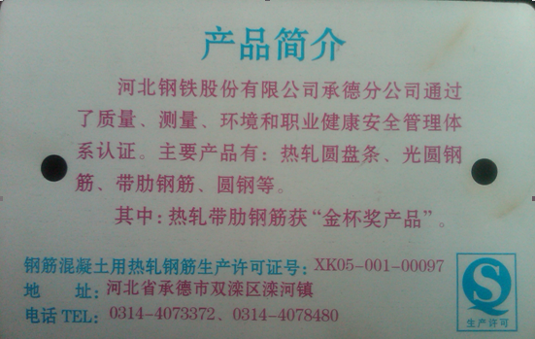
Current Nameplate of “Yanshan” Hot Rolled Ribbed Bars produced in Chengde, Hebei Province:
Front of Current Nameplate:  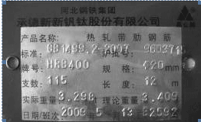 | Back of Current Nameplate:  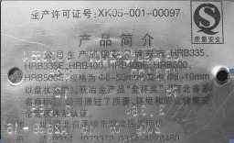

New Nameplate of “Yanshan” Hot Rolled Ribbed Bars produced in Tangshan, Hebei Province:
Front of New Nameplate:  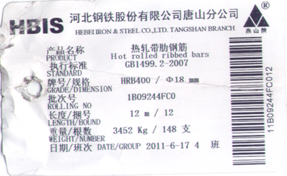 | Back of New Nameplate:  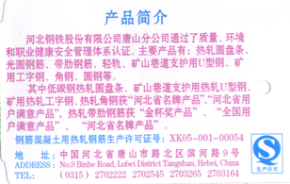
Current Nameplate of “Yanshan” Hot Rolled Ribbed Bars produced in Tangshan, Hebei Province:
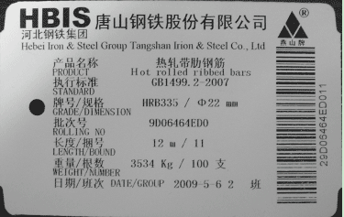
New Nameplate of “Yanshan” Hot Rolled Ribbed Bars produced in Handan, Hebei Province:
Front of New Nameplate:  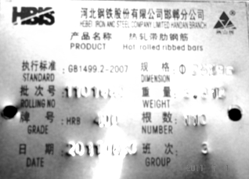 | Back of New Nameplate:  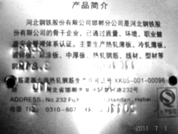
Current Nameplate of “Yanshan” Hot Rolled Steel Bars produced in Handan, Hebei Province:
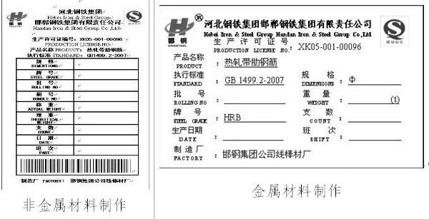

New Surface Marker of “Yanshan” Hot Rolled Ribbed Bars produced in Handan, Hebei Province:
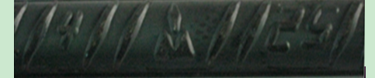

Current Surface Marker of “Yanshan” Hot Rolled Ribbed Bars produced in Handan, Hebei Province:

New Nameplate of “Yanshan” Hot Rolled Plain Bars produced in Chengde, Hebei Province:
Front of New Nameplate:  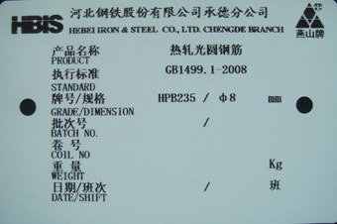 | Back of New Nameplate:
Current Nameplate of “Yanshan” Hot Rolled Plain Bars produced in Chengde, Hebei Province:
Front of Current Nameplate:  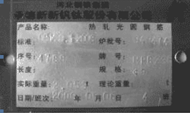 | Back of Current Nameplate:  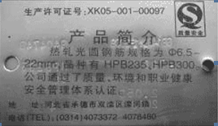
New Nameplate of “Yanshan” Hot Rolled Plain Bars produced in Tangshan, Hebei Province:
Front of New Nameplate:  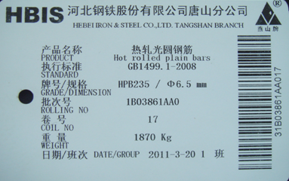 | Back of New Nameplate:
Current Nameplate of “Yanshan” Hot Rolled Plain Bars produced in Tangshan, Hebei Province:
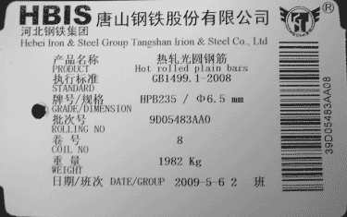
New Nameplate of “Yanshan” Hot Rolled Plain Bars produced in Xuanhua, Hebei Province:
Front of New Nameplate:  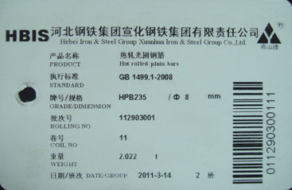 | Back of New Nameplate:  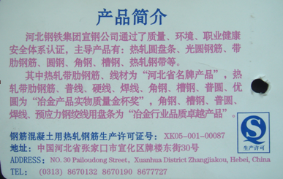
Currrent Nameplate of “Yanshan” Hot Rolled Plain Bars produced in Xuanhua, Hebei Province:
Front of Current Nameplate:  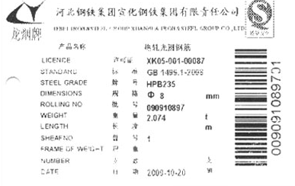 | Back of Current Nameplate:  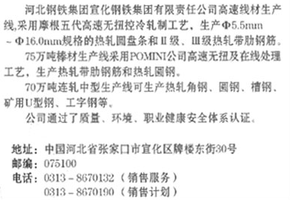

New Nameplate of “Yanshan” Hot Rolled Plain Bars produced in Handan, Hebei Province:
Front of New Nameplate:  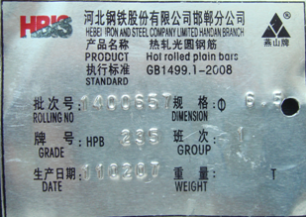 | Back of New Nameplate:  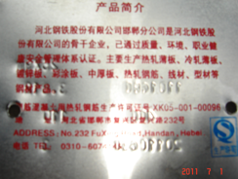
Current Nameplate of “Yanshan” Hot Rolled Plain Bars produced in Handan, Hebei Province:
