Appendix:
Current and New Nameplates of Wuyang Hot Rolled Ribbed Bars
New Nameplates of Wuyang Hot Rolled Ribbed Bars:
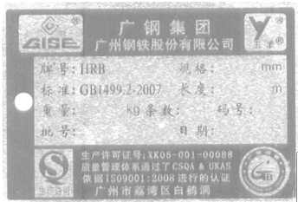
Current Nameplates of Wuyang Hot Rolled Ribbed Bars:
