Appendix:
Current and New Nameplates of Jianlong Hot Rolled Ribbed Bars
New Nameplates of Jianlong Hot Rolled Ribbed Bars:
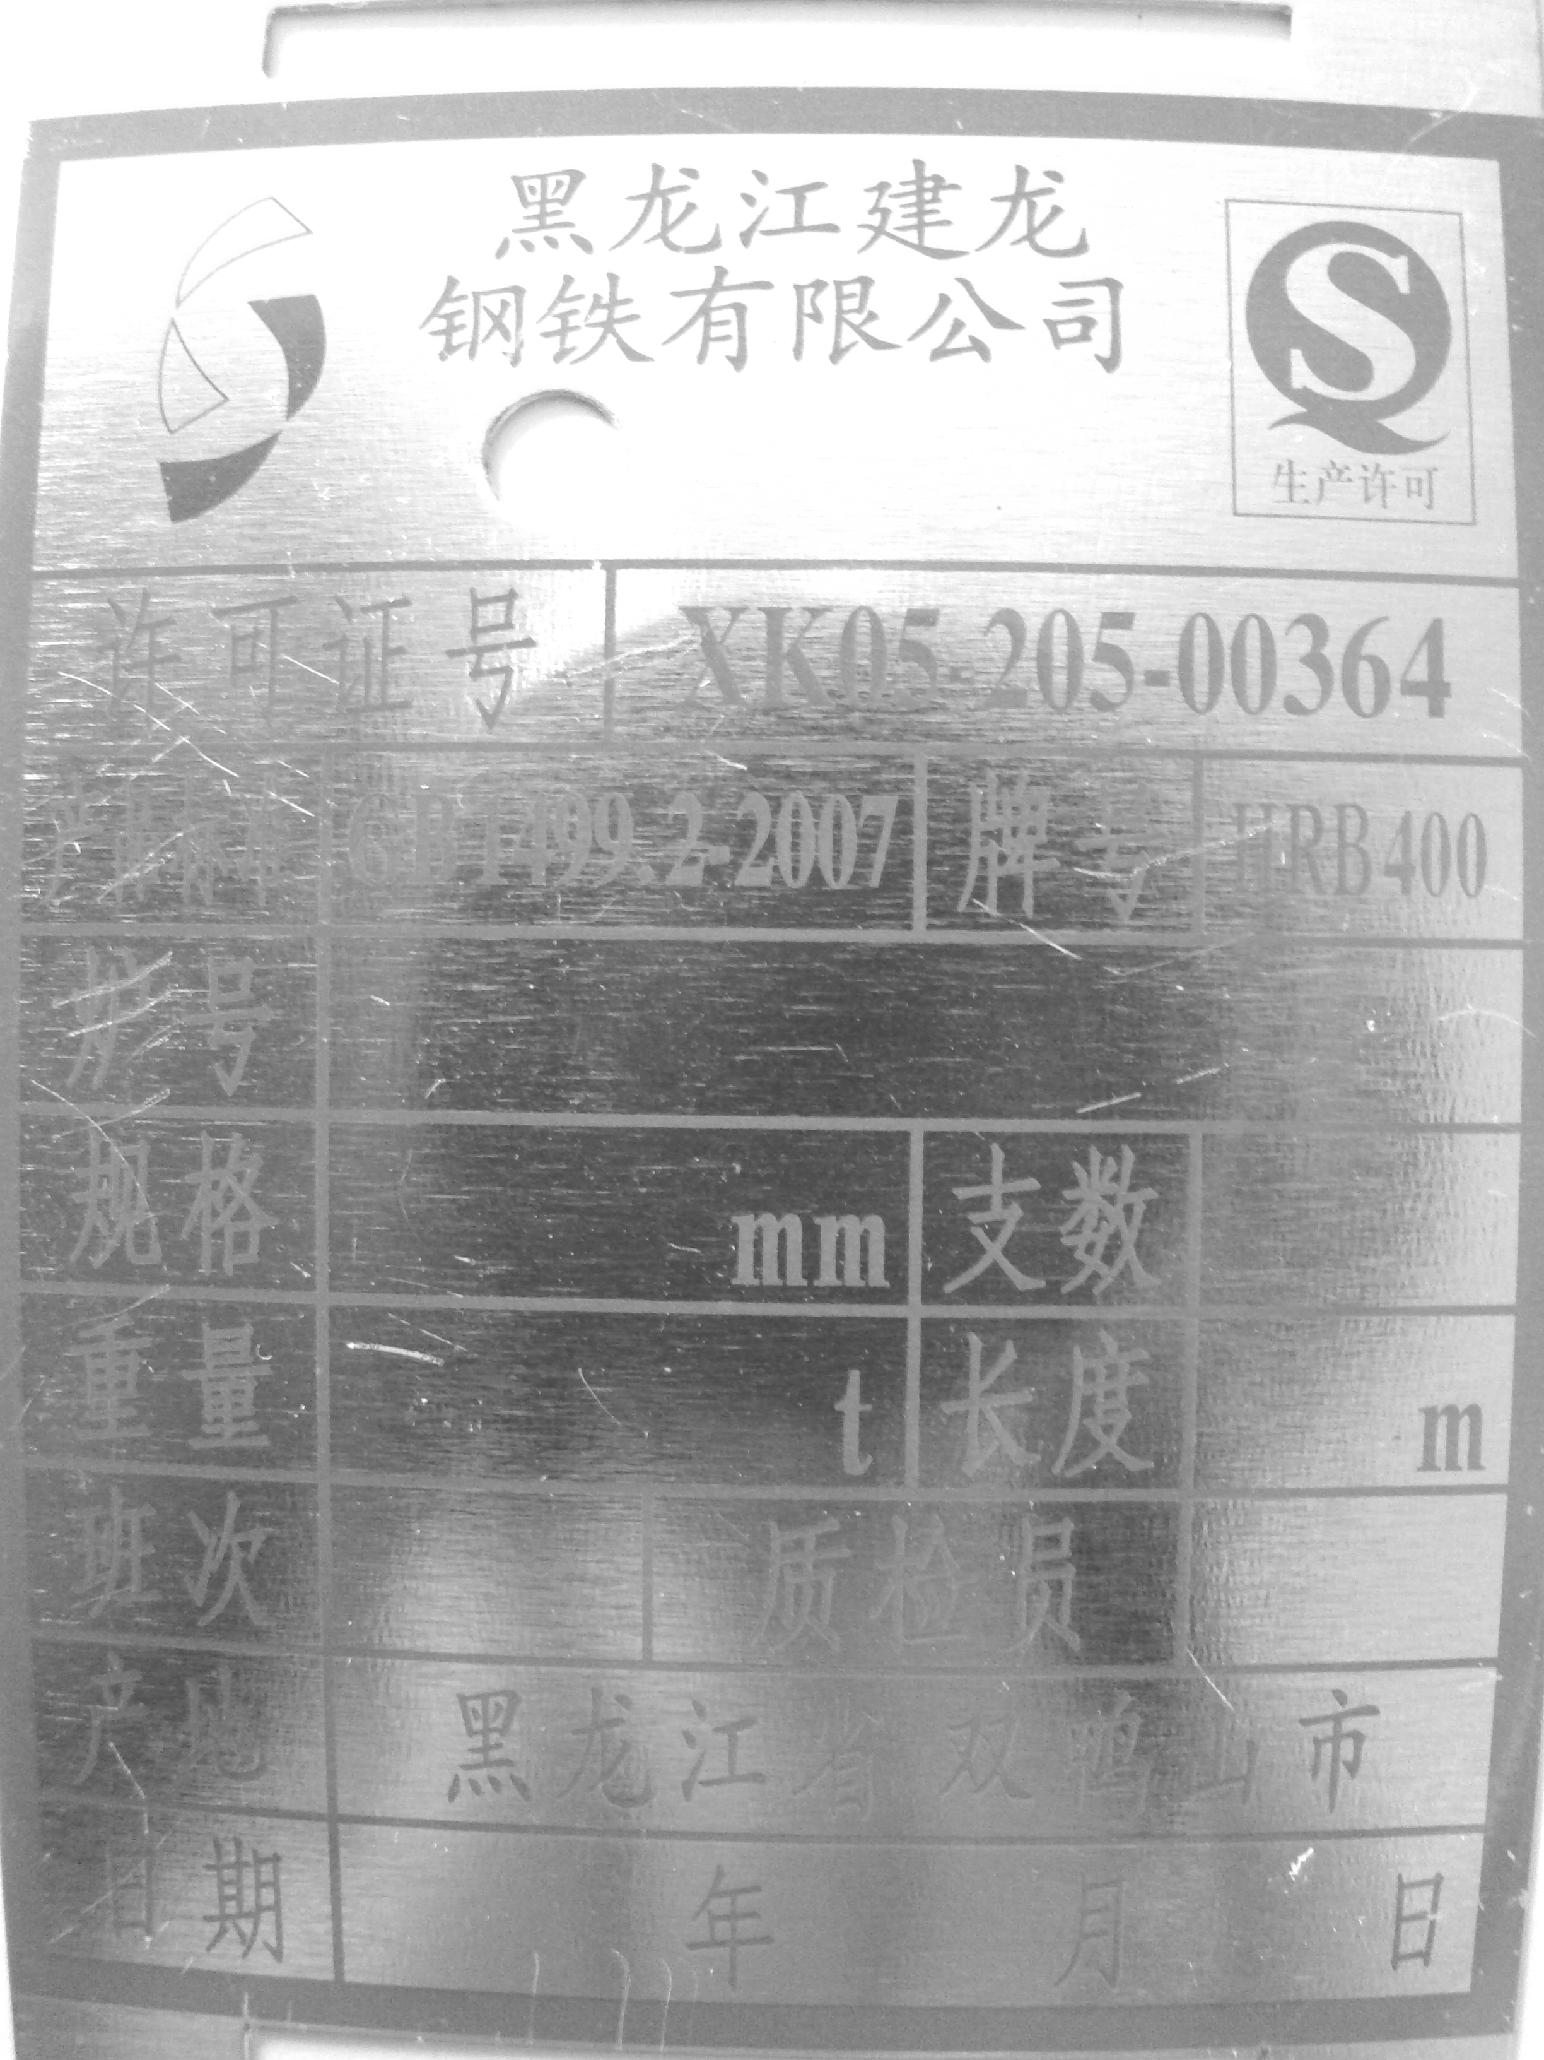
Current Nameplates of Jianlong Hot Rolled Ribbed Bars
