Appendix：
Current and New Nameplates of Laiwu Hot Rolled Ribbed Bars
New Nameplates of Laigang Hot Rolled Ribbed Bars:

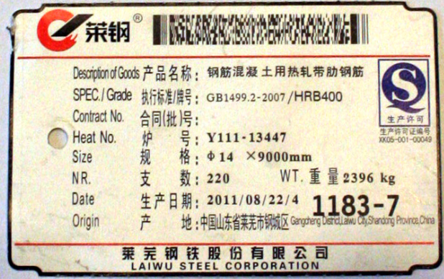
Current Nameplates of Laigang Hot Rolled Ribbed Bars:

