Appendix:
Old and New Surface Markers of “Yanshan” Brand Hot rolled Ribbed Bars
New Surface Marker of “Yanshan” Brand Hot rolled Ribbed Bars (Place of origin: Tangshan, Hebei)
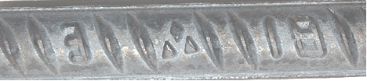
Current Surface Marker of “Yanshan” Brand Hot rolled Ribbed Bars (Place of origin: Tangshan, Hebei)
