Appendix:
Current and New Products and Nameplates of “Yunnan Aluminum” Brand
New aluminum ingot and nameplate: (As showed below)
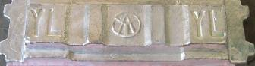
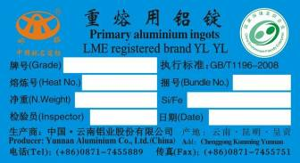
Current aluminum ingot and nameplate: (As showed below)
