Appendix:
Current and New Packages of SKS Brand Lead (Pb99.994)
New product package: (as showed below)
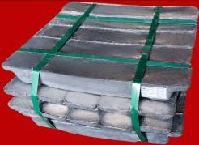
Current product package: (as showed below)
