Appendix 3：
Identifications Such As the Dimension, Weight, Outer Packing, Steel Seal, and Quality Certificate, etc. of Menglong Rubber Plant SCR WF

Dimension: 600*400*200 mm
Weight per package: Net 40 kg
Each delivery unit (5 tons): Consisting of 125 packages
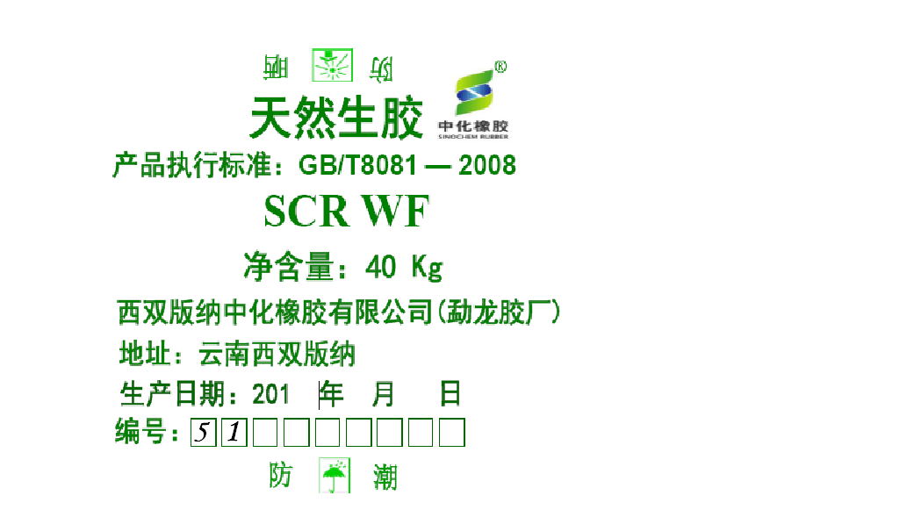
The first two digits of the product outer packing woven bag’s number are “51”
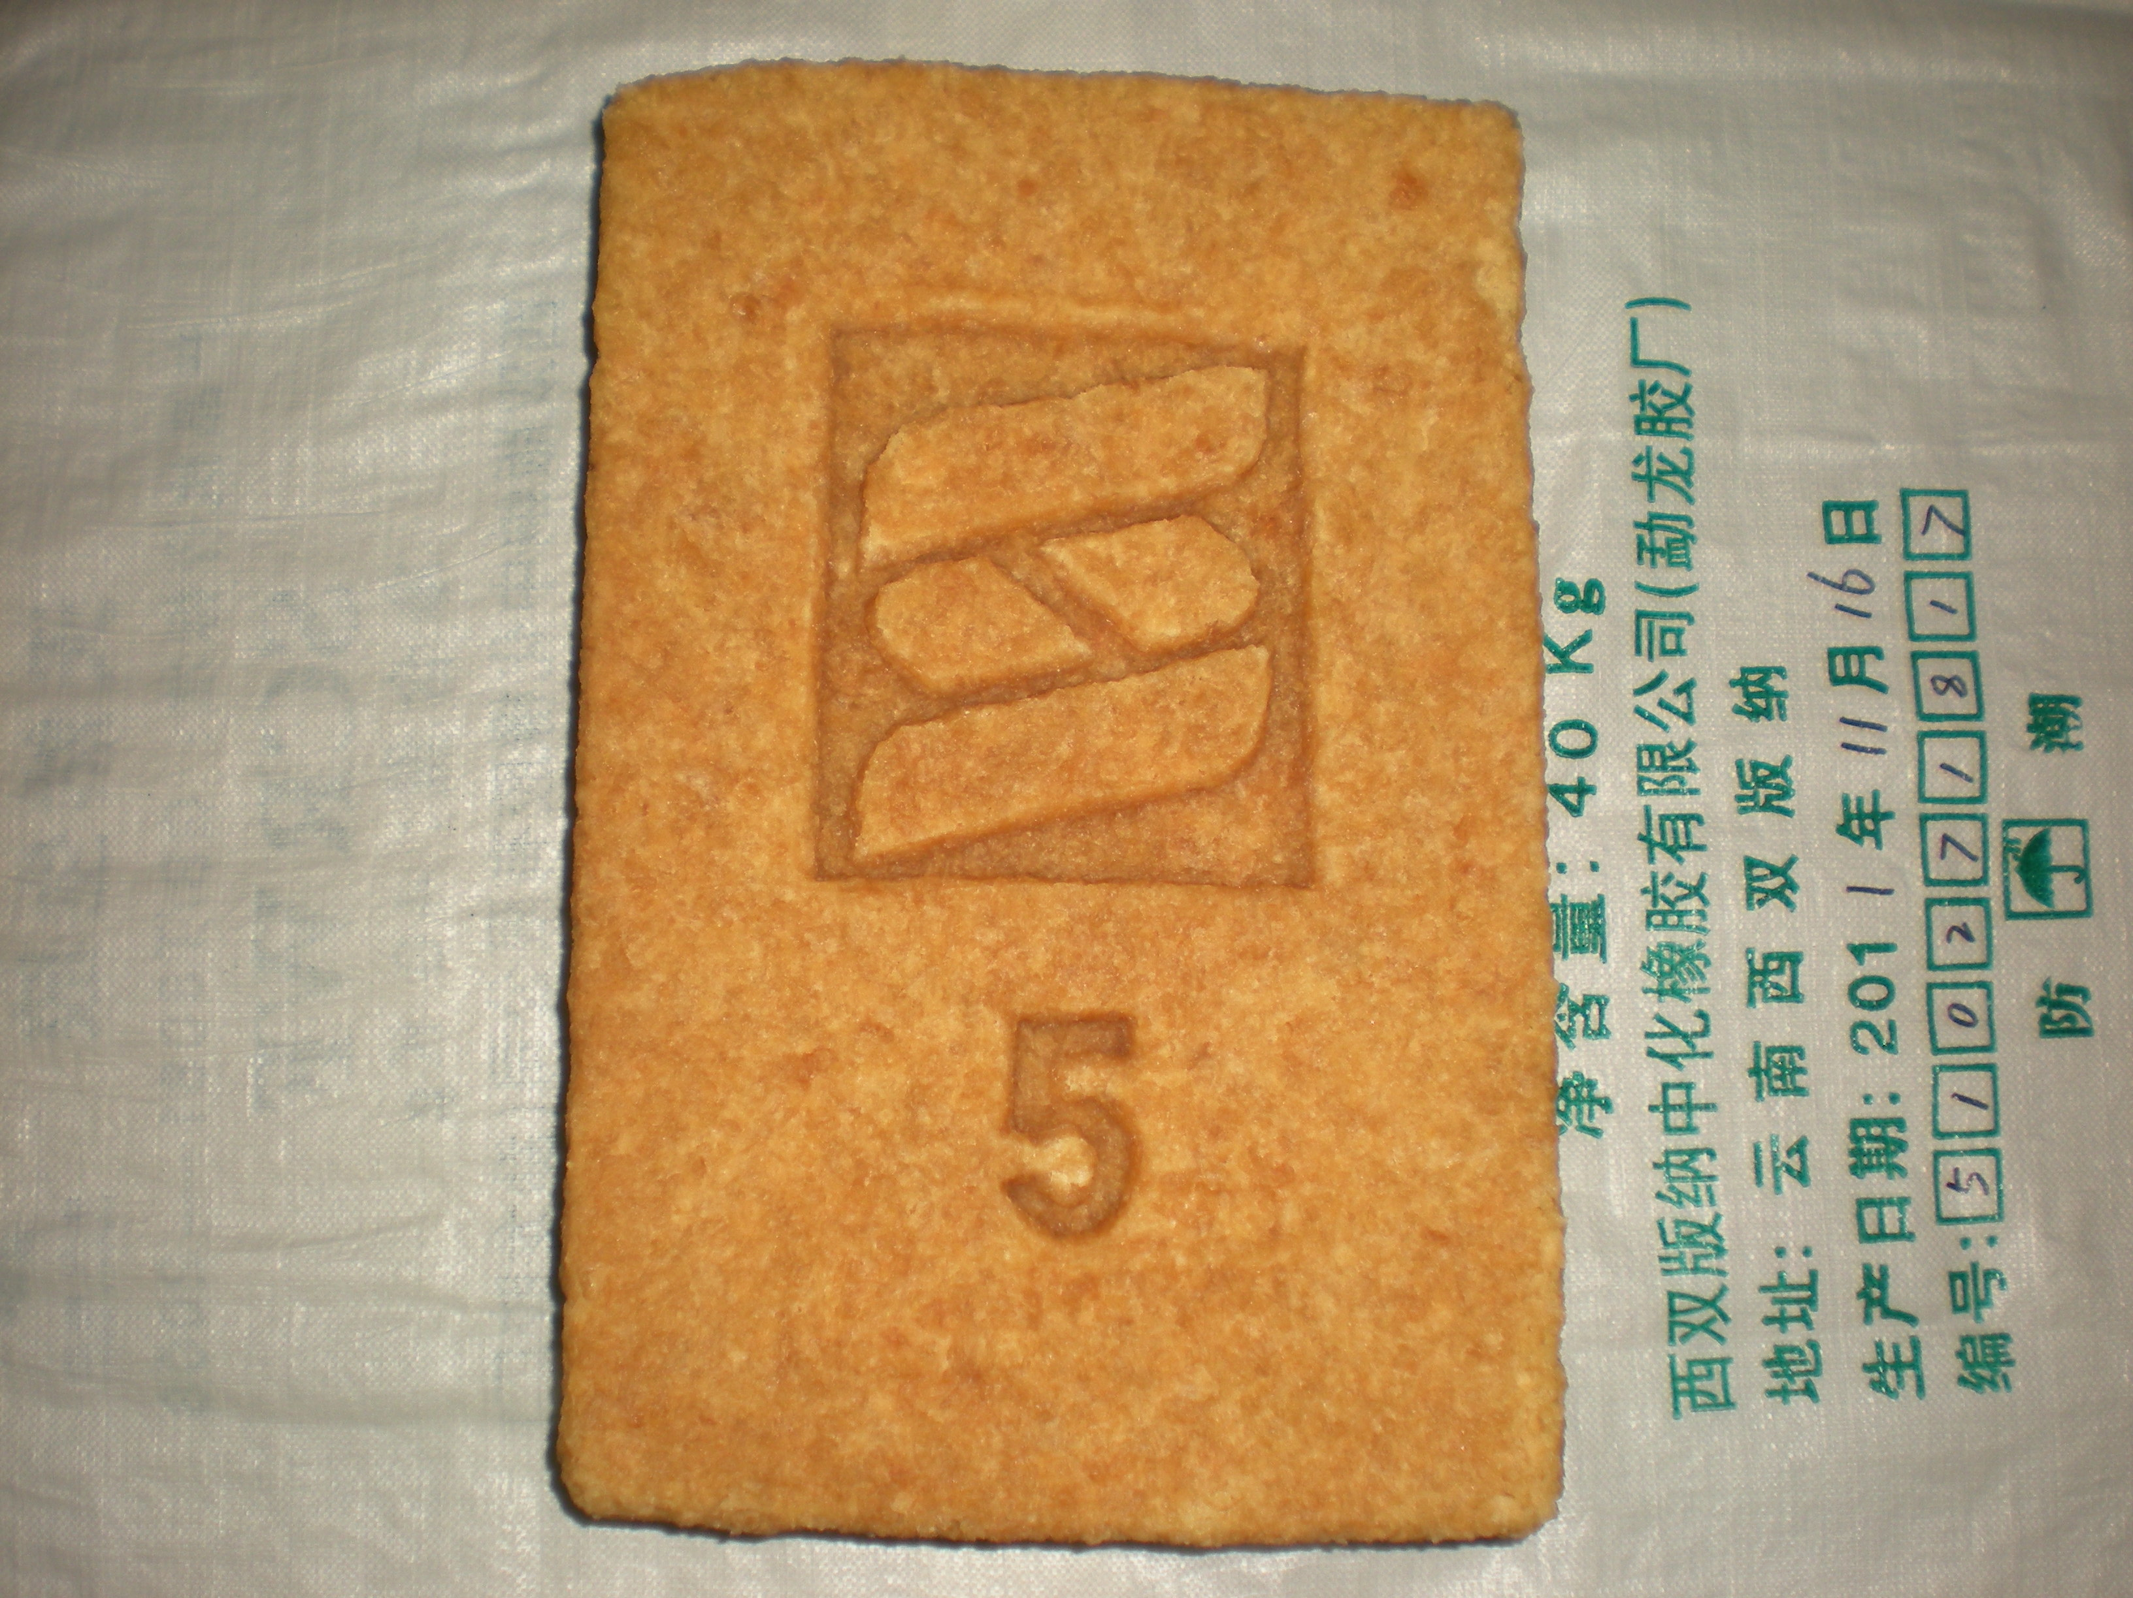
“Sinochem Rubber” figurative mark and plant code “5” are printed on rubber block products

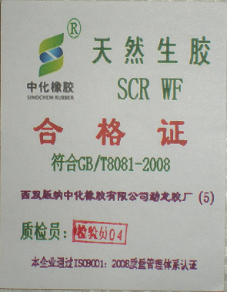
Certificate sample

