Appendix：

Current and New Nameplates of Magang Hot-rolled Ribbed Bars and Hot-rolled Plain Bars

New Nameplate of Magang Hot-rolled Ribbed Bars: (Place of origin: Maanshan, Anhui Province)
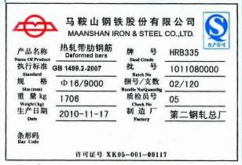
Current Nameplate of Magang Hot-rolled Ribbed Bars: (Place of origin: Maanshan, Anhui Province)
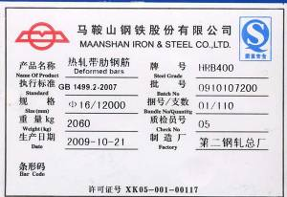

New Nameplate of Magang Hot-rolled Ribbed Bars: (Place of origin: Hefei, Anhui Province)
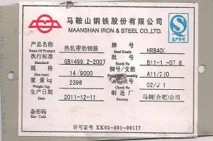
Current Nameplate of Magang Hot-rolled Ribbed Bars: (Place of origin: Hefei,, Anhui Province)

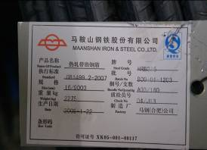
New Nameplate of Magang Hot-rolled Plain Bars (Place of origin: Maanshan, Anhui Province)
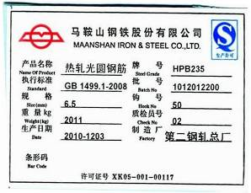

Current Nameplate of Magang Hot-rolled Plain Bars (Place of origin: Maanshan, Anhui Province)
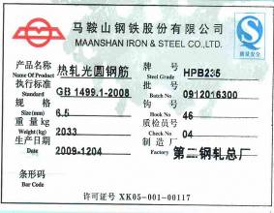
New Nameplate of Magang Hot-rolled Plain Bars (Place of origin: Hefei, Anhui Province)
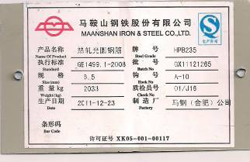
Current Nameplate of Magang Hot-rolled Plain Bars (Place of origin: Hefei, Anhui Province)
