Appendix：
Current and New Nameplates of Haixin Hot-rolled Ribbed Bars and Hot-rolled Plain Bars

New Nameplate of Haixin Hot-rolled Ribbed Bars:
The front of new nameplate：  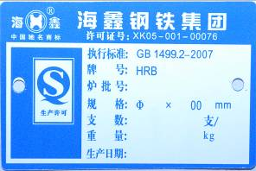 | The back of new nameplate：  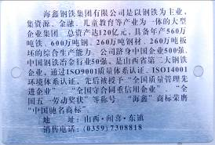

Current Nameplate of Haixin Hot-rolled Ribbed Bars:
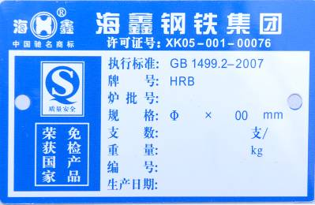

New Nameplate of Haixin Hot-rolled Plain Bars
The front of new nameplate：  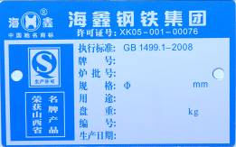 | The back of new nameplate：  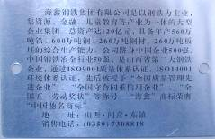

Current Nameplate of Haixin Hot-rolled Plain Bars
