Appendix:
New and Current surface marker and Nameplate of “Fuxin” Brand Hot-Rolled Ribbed Bars
New Nameplate of “Fuxin” Brand Hot-Rolled Ribbed Bars
Front of New Nameplate:  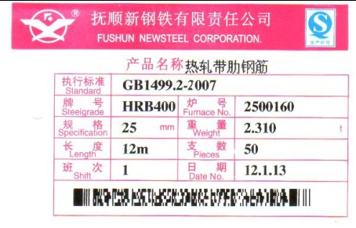 | Back of New Nameplate:  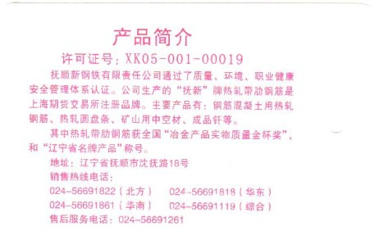
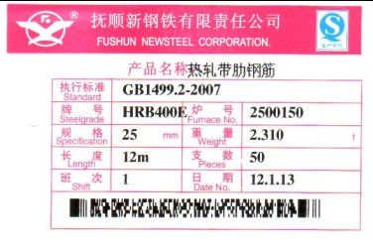
Current Nameplate of “Fuxin” Brand Hot-Rolled Ribbed Bars
Front of Current Nameplate:  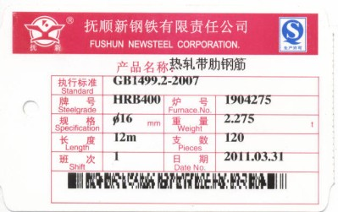 | Back of Current Nameplate:  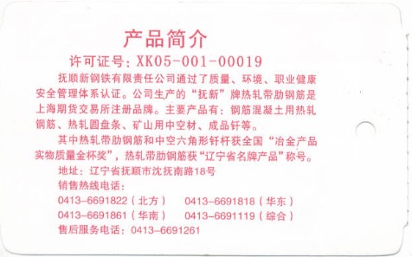
New Surface Marker of “Fuxin” Brand Hot-Rolled Ribbed Bars
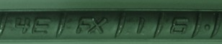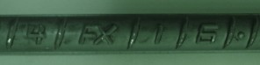
Current Surface Marker of “Fuxin” Brand Hot-Rolled Ribbed Bars
