Appendix:

Member User's Operating Manual for Electronic Platform System for Large Trader Report

Large Trader Report(LTR)
The Exchange adopts the large trader reporting system. When speculative position in member's or investor's open contract of certain product reached 80% of the Max. position limit on speculative position as prescribed by the Exchange, members or investors shall report the information on its/his funds or position to the Exchange. In which, investors must report via a futures firm member
On homepage of member service system, the following message appeared under Large Trader Report under the Notification on Daily Risk Control and Tips column that the login member " has totally (N) messages to be submitted and (N) messages have been returned, which have to be recompleted after re-start".

1.1 Submission of Large Trader Report
Members submits large trader report to the Exchange. Subject of large trader report mainly consists of three type: futures firm member, non-futures firm member and client.
Operational steps：
1．Select the Business Window→Large Trader Report→ Submission of Large Trader Report; input the date of trading in column of "Query Terms" to query for the large trader report under such date; meanwhile, the un-submitted large trader report was displayed at the bottom of this page.
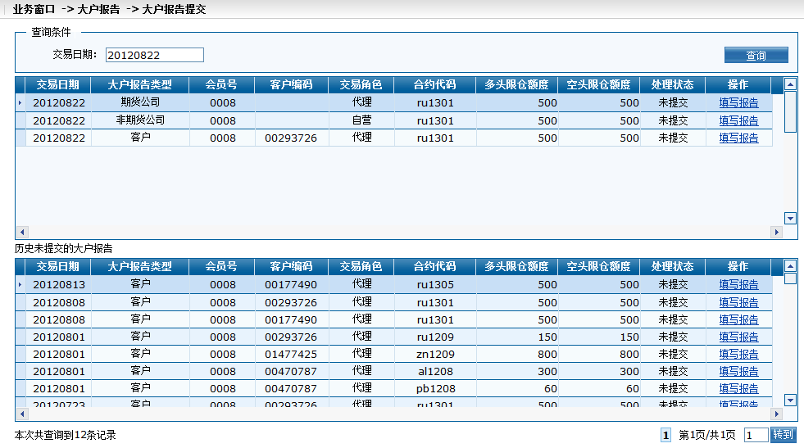
Fig. 1.1-1 Submission of large trader report
2. As for report in the state of un-submitted, please click "Complete the Report" in operation column. Then there will be a pop-up window for completing the report on this page. In which, please note: as for futures firm member, the information on investor shall be filled in large trader report; as for non-futures firm member, transaction settlement documents shall be uploaded in large trader report. The following figure is an illustration made by taking the client's large trader report as example
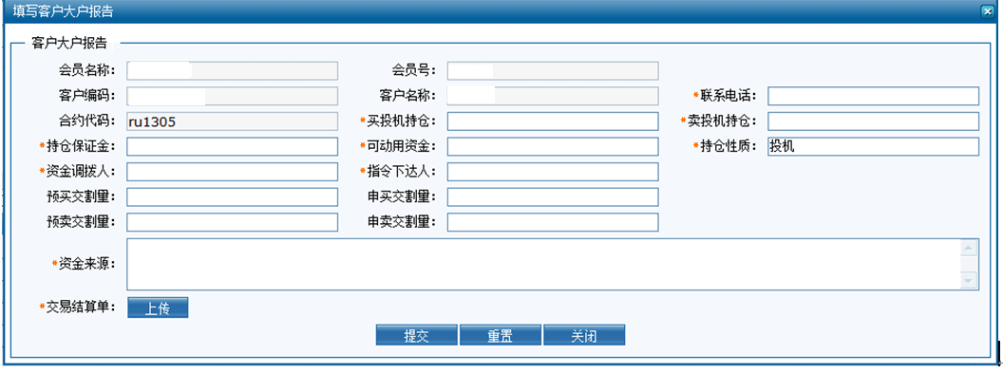
Fig 1.1-2 Large trader report of client member
3. Complete the contents such contact number, long/short speculative position, available funds in the report. In which, the item with a red star mark must be completed; the transaction settlement document will be chopped by futures firm and scanned into jpg, jpeg, png or PDF format for uploading;
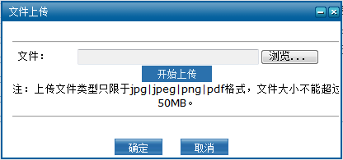
Fig 1.1-1 Attachment of client member's large trader
4．Click "Submission", and the system prompt indicates that information on large trader report was successfully inserted.
5．State of such message after submitted is "initial submission". Report can be modified under this state;
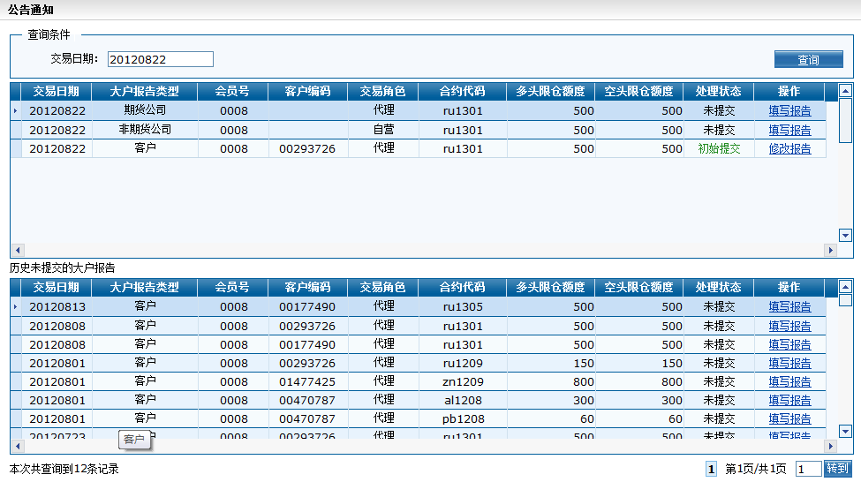
Fig. 1.1-2 Initial submission of client member's large trader report
6．After verified by the Exchange, the results will be rejected or approved；
a）If large trader report is rejected by the Exchange, the system will show the status "Rejected by the Exchange"; then click "Modification of Report" and the reason for being rejected by the Exchange will show in the report. Report will be resubmitted after modification.
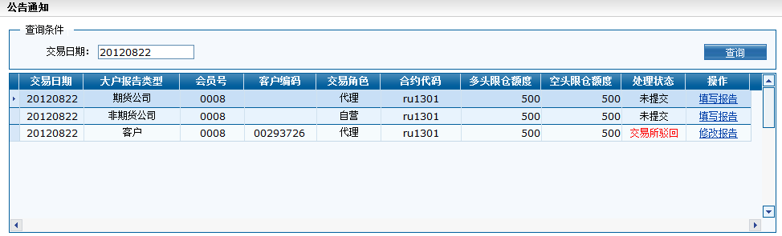
Fig.1.1-3 Client member's large trader was rejected
b）When large trader report was approved, the processing status column shows " Approved" without the needs for any operation.
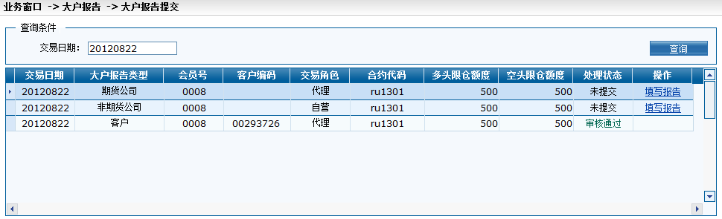
Fig. 1.1-4 Member's large trader report was approved

1.2 Large Trader Report Management
Member may look at current status of various types of large report via Large Trader Report Management
Operational steps：
1．1．Select the Business Window→Large Trader Report→ Large Trader Report Management; input the arbitrary items such as date of trading, type of large trader report, investor's code and processing status in column of "Query Terms" to query for the status of large trader report under such conditions.
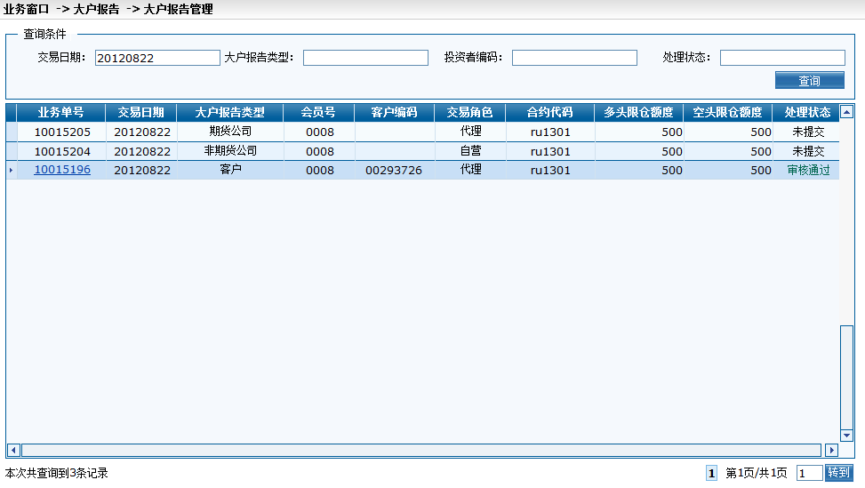
Fig 1.2-5 Large Trader Report Management
2．Click the underlined business No. to look at detailed contents of such report.
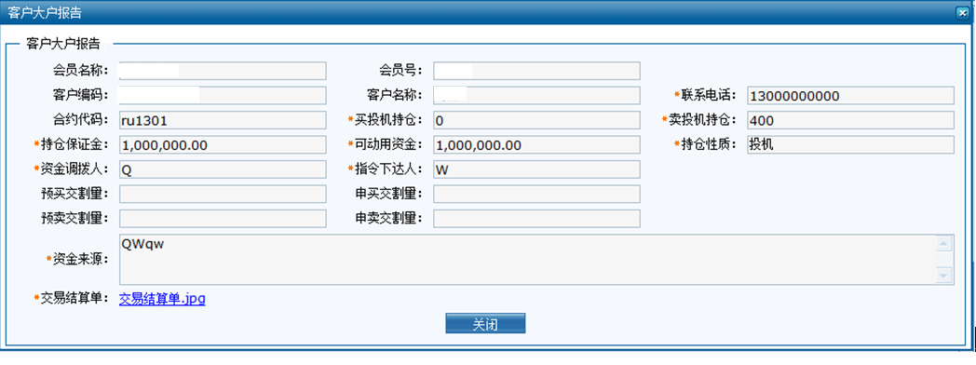
Fig. 1.2-6 Large trader report of the client

