Appendix

New and Existing Nameplates of “Tong Guan” 15kg Silver Ingot

Existing Nameplate of “Tong Guan” 15kg Silver Ingot:
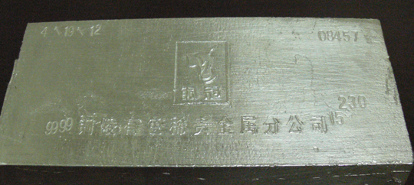

New Nameplate of “Tong Guan” 15kg Silver Ingot:
