Appendix

Ingot Surface and Logo of “RUSAL I” Aluminum Ingot (AL99.70) for Remelting and the Former Product

Ingot surface of current product: (as shown in the Fig.)

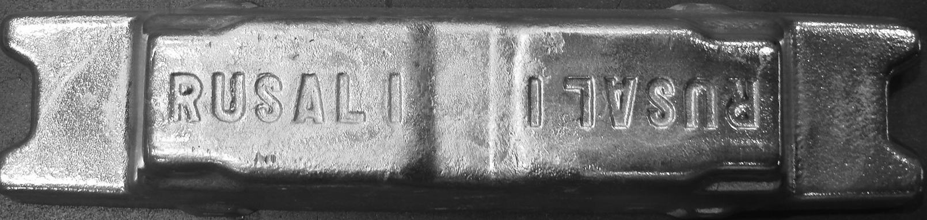

Ingot surface of former product: (as shown in the Fig.)

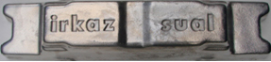

Logo of current product: (as shown in the Fig.)

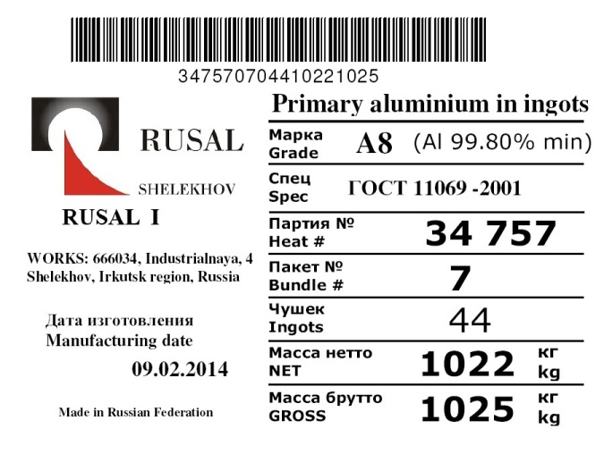

Logo of former product: (as shown in the Fig.)

