Appendix

[**New and Existing Nameplates of “Shuang Ling” Hot-rolled Ribbed Bars and “Xiang Gang” Hot-rolled Plain Bars**](http://www.shfe.com.cn/upload/20140113/1389603904124.doc)

New Nameplate of “Shuang Ling” Hot-rolled Ribbed Bars:

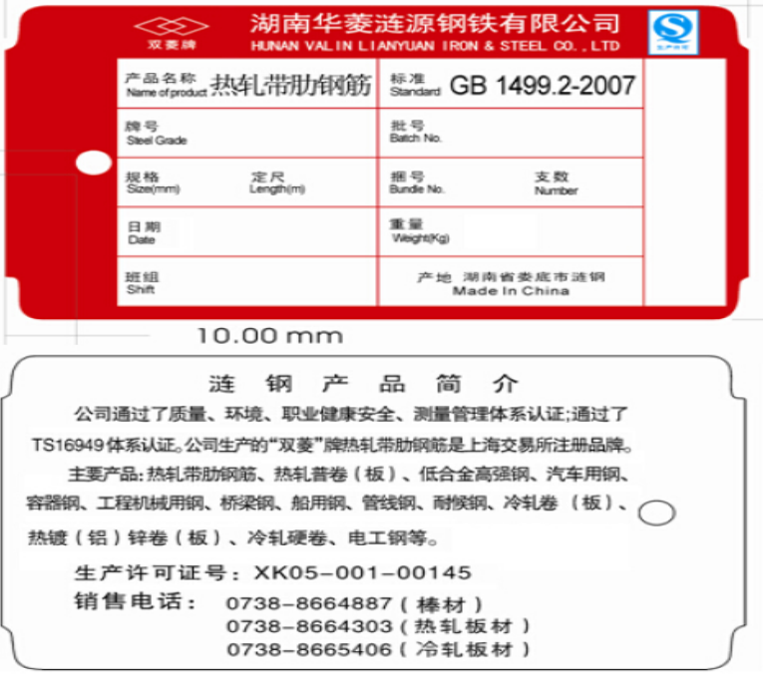

Existing Nameplate of “Shuang Ling” Hot-rolled Ribbed Bars:

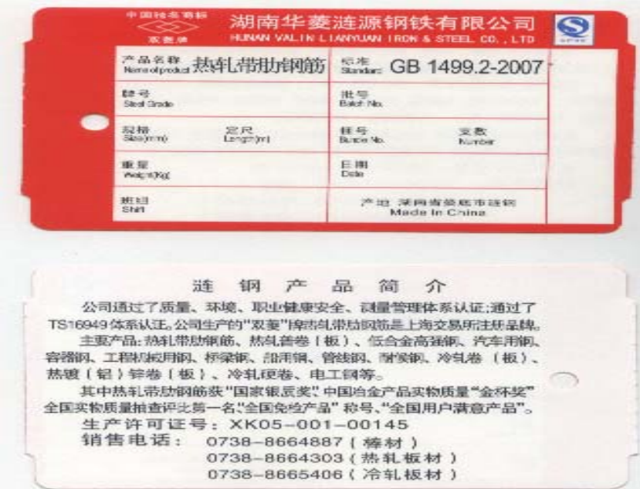

New Nameplate of “Xiang Gang” Hot-rolled Plain Bars:

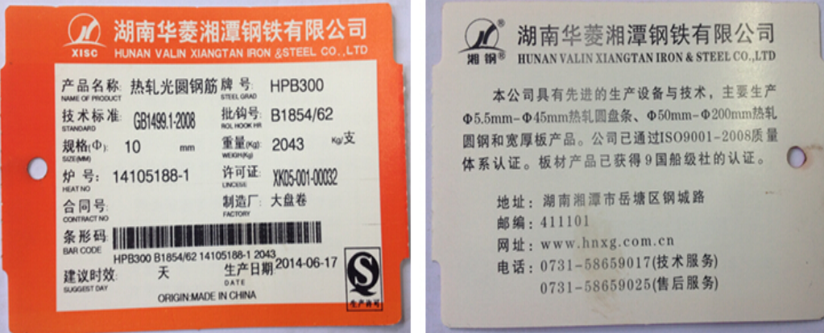

Existing Nameplate of “Xiang Gang” Hot-rolled Plain Bars: ：

