**Appendix**

**New and Existing Surface Markers of “Changqiang” Brand Hot-rolled Ribbed Bars**

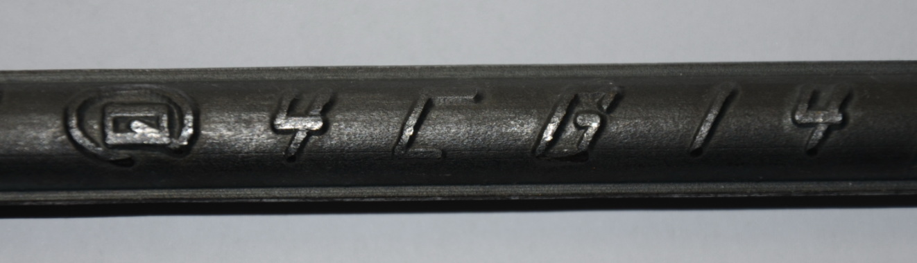**New Surface Marker of “Changqiang” Brand Hot-rolled Ribbed Bars**

**Existing Surface Marker of “Changqiang” Brand Hot-rolled Ribbed Bars**

