**Appendix**

**New and Existing Product Nameplates of “Xinxing” Brand Hot-rolled Ribbed Bars**

Front Side of New Product Nameplate Back Side of New Product Nameplate

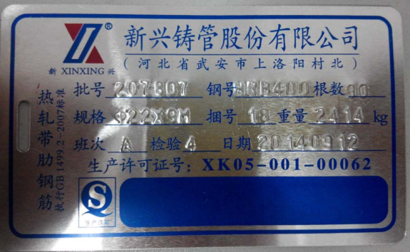（Place of Origin：Wu‘an, Hebei Province）： （Place of Origin：Wu’an, Hebei Province）：

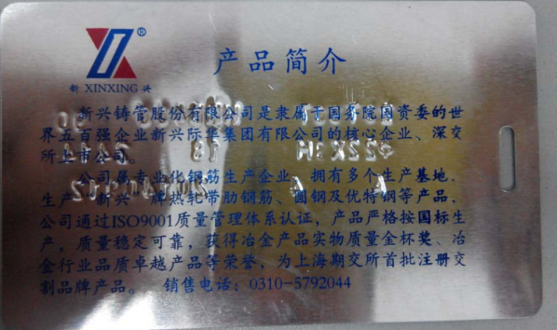

Front Side of Existing Product Nameplate

（Place of Origin：Wu’an, Hebei Province）：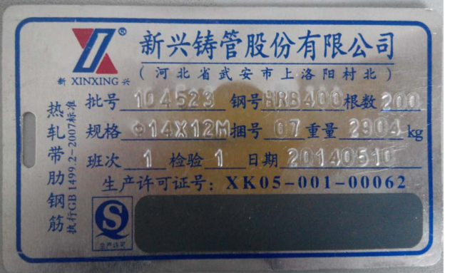

Note：There are no contents on the back side of existing product nameplate.

Front Side of New Product Nameplate Back Side of New Product Nameplate

（Place of Origin：Wuhu, Anhui Province）： （Place of Origin：Wuhu, Anhui Province）：

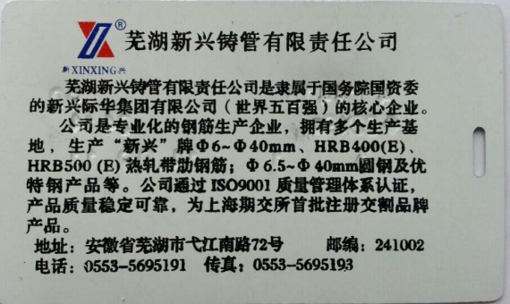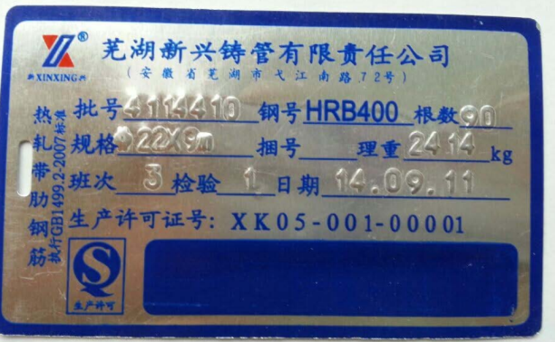

Front Side of Existing Product Nameplate

（Place of Origin：Wuhu, Anhui Province）：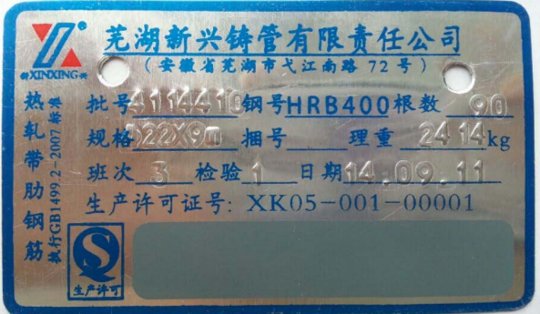

Note：There are no contents on the back side of existing product nameplate.