**Appendix**

**New and Existing Product Nameplates of “Shagang” Brand Hot-rolled Ribbed Bars and Hot-rolled Round Bars**

**New Product Nameplate of “Shagang” Brand Hot-rolled**

**Ribbed Bars HRB400**

Front Side of New Product Nameplate Back Side of New Product Nameplate

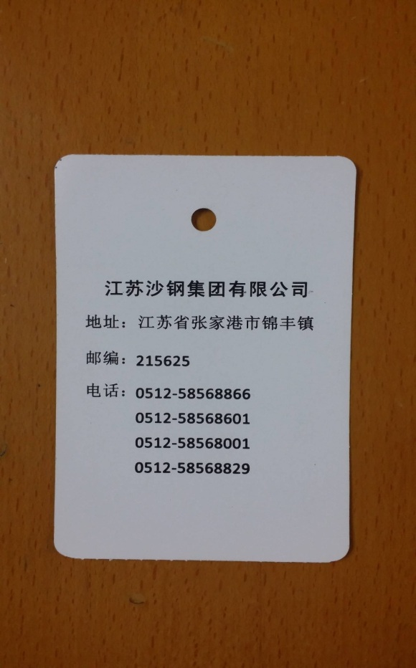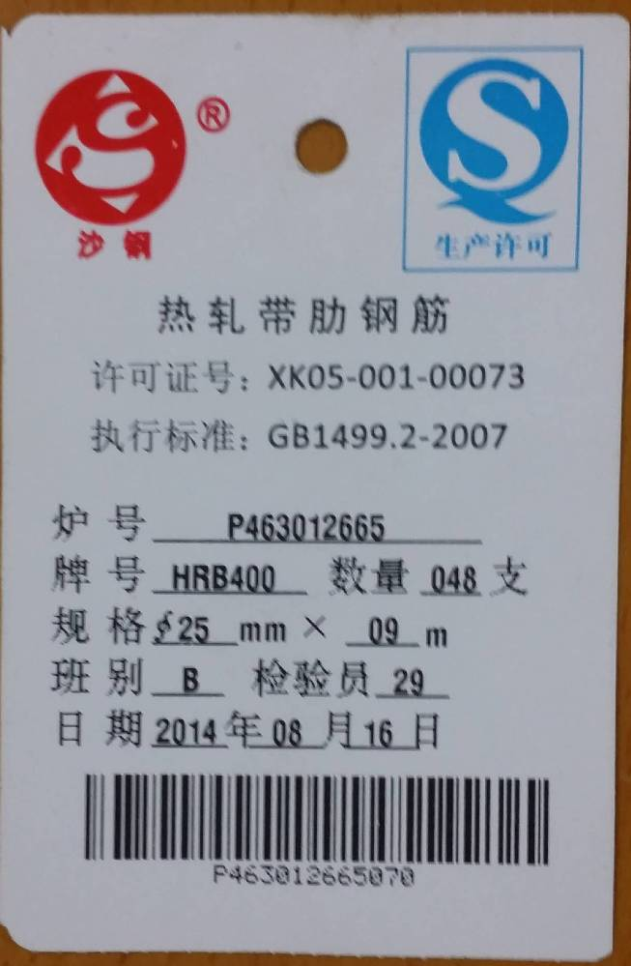

**Existing Product Nameplate of “Shagang” Brand Hot-rolled**

**Ribbed Bars HRB400**

Front Side of Existing Product Nameplate Back Side of Existing Product Nameplate

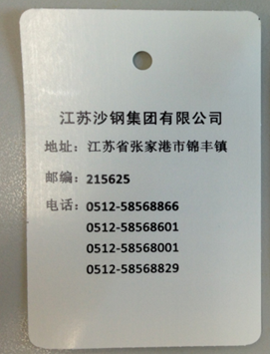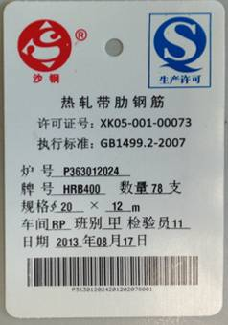

**New Product Nameplate of “Shagang” Brand Hot-rolled**

**Ribbed Bars HRB335**

Front Side of New Product Nameplate Back Side of New Product Nameplate

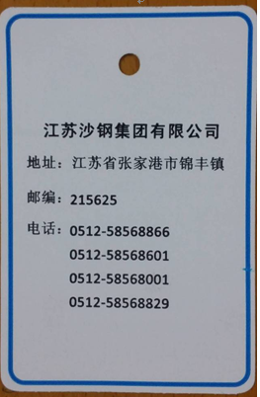 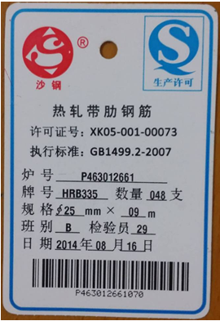

**Existing Product Nameplate of “Shagang” Brand Hot-rolled**

**Ribbed Bars HRB335**

Front Side of Existing Product Nameplate Back Side of Existing Product Nameplate

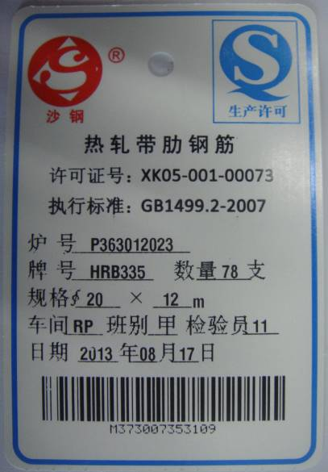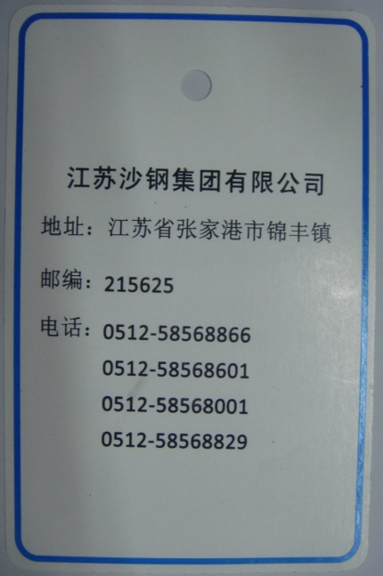

**New Product Nameplate of “Shagang” Brand Hot-rolled**

**Plain Bars HPB235**

Front Side of New Product Nameplate Back Side of New Product Nameplate

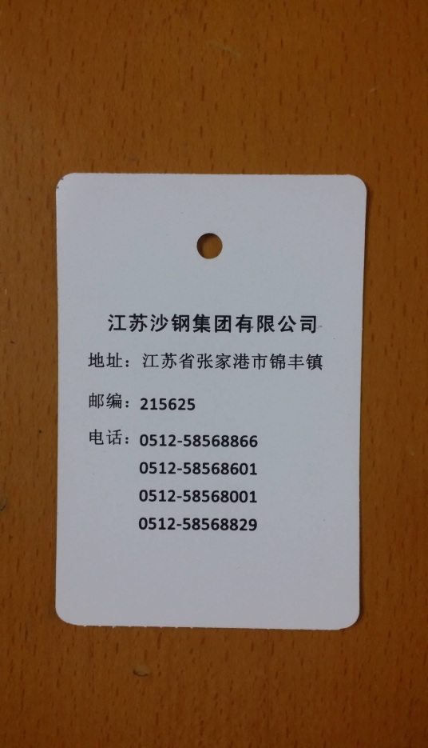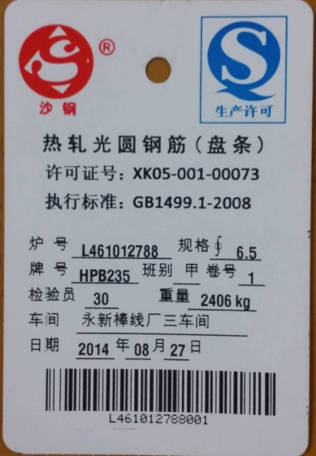

**Existing Product Nameplate of “Shagang” Brand Hot-rolled**

**Plain Bars HPB235**

Front Side of Existing Product Nameplate Back Side of Existing Product Nameplate

