**Appendix**

**New and Existing Product Nameplates of “Minguang” Brand Hot-rolled Ribbed Bars**

**New Product Nameplate of “Minguang” Brand**

**Hot-rolled Ribbed Bars**

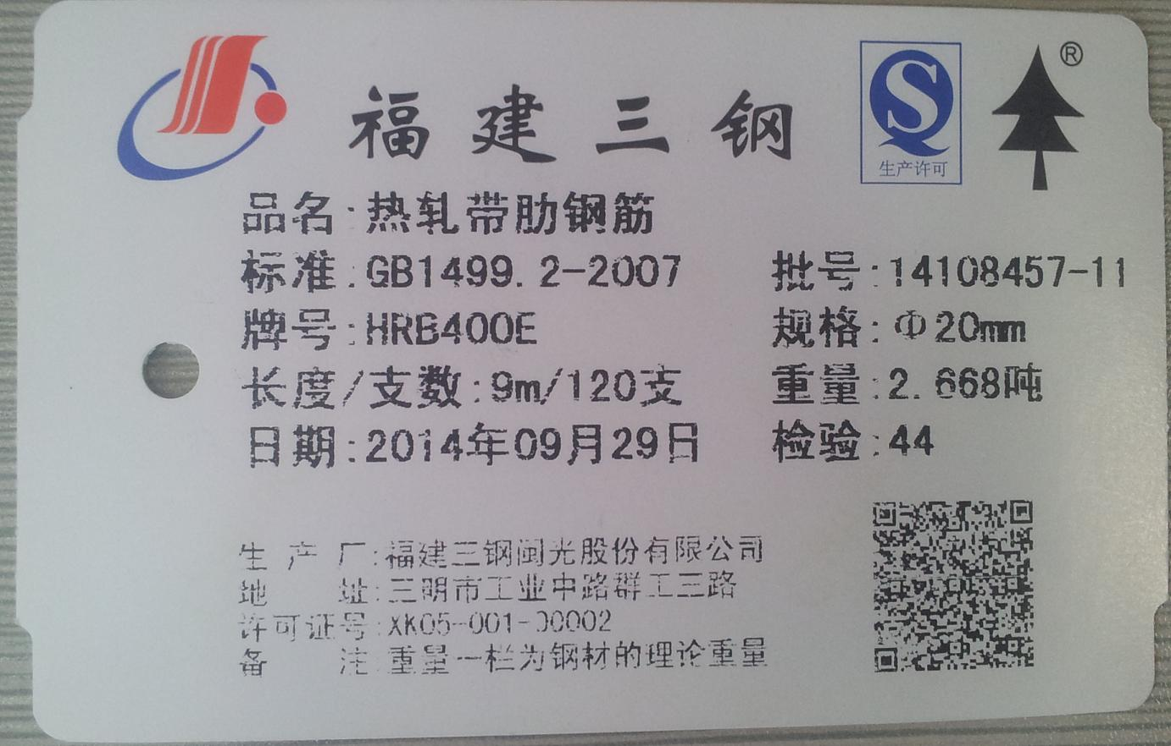

**Existing Product Nameplate of “Minguang” Brand**

**Hot-rolled Ribbed Bars**

