**Appendix**

**New and Existing Product Nameplates, Goods Marksand Number of Packing Pieces of “Yufeng” Brand Hot-rolled Ribbed Bars**

New goods mark

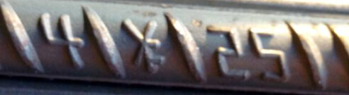

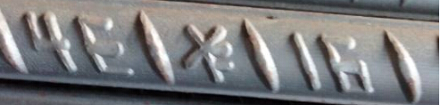

Existing goods mark

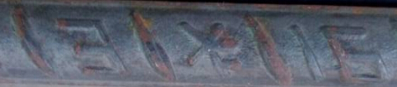



New product nameplate

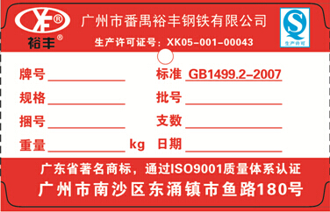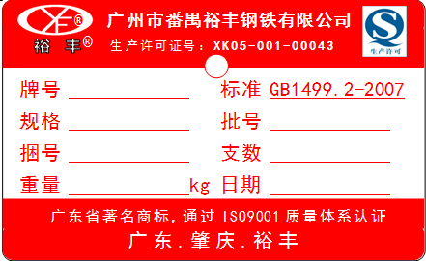

Existing product nameplate

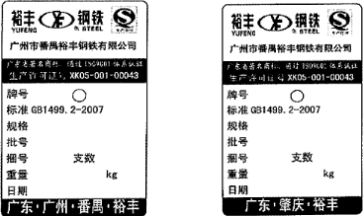

**Number of Packing Pieces of New Product**

|  |  |  |  |  |  |  |
| --- | --- | --- | --- | --- | --- | --- |
| Place of Origin | Brand | Diameter (mm) | Length (m) | Piece/  Bundle | Set Weight (KG) | Bundle/  Lot |
| Nansha, Guangdong Province  Zhaoqing, Guangdong Province | HRB400  HRB400E | 16 | 9 | 180 | 2560 | 117 |
| 12 | 135 | 2560 | 117 |
| 18 | 9 | 140 | 2520 | 119 |
| 12 | 110 | 2640 | 114 |
| 20 | 9 | 115 | 2556 | 117 |
| 12 | 90 | 2668 | 112 |
| 22 | 9 | 95 | 2548 | 118 |
| 12 | 75 | 2682 | 112 |
| 25 | 9 | 75 | 2599 | 115 |
| 12 | 55 | 2541 | 118 |

Packing: bundled up evenly and firmly using steel straps or steel wire rods with no less than 4 straps.

Executive Standard: GB1499.2-2007

**Number of Packing Pieces of Existing Product**

|  |  |  |  |  |  |  |
| --- | --- | --- | --- | --- | --- | --- |
| Place of Origin | Brand | Diameter (mm) | Length (m) | Piece/  Bundle | Set Weight (KG) | Bundle/  Lot |
| Fanyu, Guangdong Province  Zhaoqing, Guangdong Province | HRB400  HRB335 | 16 | 9 | 200 | 2844 | 105 |
| 12 | 150 | 2844 | 105 |
| 18 | 9 | 160 | 2880 | 104 |
| 12 | 130 | 3120 | 96 |
| 20 | 9 | 130 | 2890 | 104 |
| 12 | 110 | 3260 | 92 |
| 22 | 9 | 110 | 2950 | 102 |
| 12 | 90 | 3218 | 93 |
| 25 | 9 | 90 | 3119 | 96 |
| 12 | 70 | 3234 | 93 |

Packing: bundled up evenly and firmly using steel straps or steel wire rods with no less than 4 straps.

Executive Standard: GB1499.2-2007