Appendix

New and Existing Surface Logos

of 15Kg Silver Bullion

New Surface Logo of 15Kg Silver Bullion

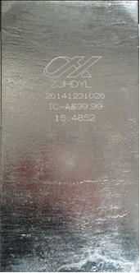

Existing Surface Logo of 15Kg Silver Bullion

