Appendix

New and Existing Nameplates and Surface Markers of *YANSHAN* Brand Hot-rolled Ribbed Bars

**（Ⅰ）Hebei Iron & Steel Co., Ltd. Tangshan Branch**

New Surface Marker of *YANSHAN* Brand Hot-rolled Ribbed Bar ( Place of Origin: Tangshan, Hebei Province)：

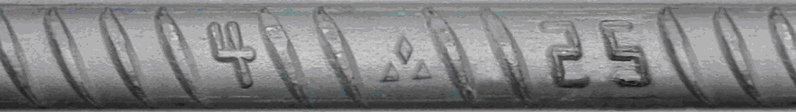

Existing Surface Marker of YANSHAN Brand Hot-rolled Ribbed Bar ( Place of Origin: Tangshan, Hebei Province)：

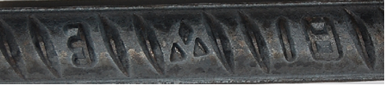

**（Ⅱ）Hebei Iron & Steel Co., Ltd. Handan Branch**

New Surface Marker of YANSHAN Brand Hot-rolled Ribbed Bar ( Place of Origin: Handan, Hebei Province)：

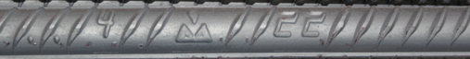

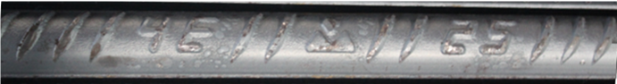

Existing Surface Marker of *YANSHAN* Brand Hot-rolled Ribbed Bar ( Place of Origin: Handan, Hebei Province)：



**（Ⅲ）Hebei Iron & Steel Co., Ltd. Chengde Branch**

New Surface Marker of *YANSHAN* Brand Hot-rolled Ribbed Bar ( Place of Origin: Chengde, Hebei Province)：

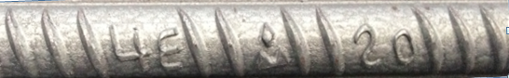

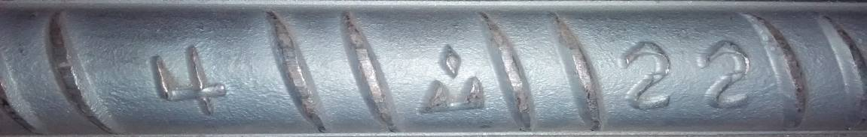

Existing Surface Marker of *YANSHAN* Brand Hot-rolled Ribbed Bars ( Place of Origin: Chengde, Hebei Province)：



**The number of pieces per bundle and weight per bundle of *YANSHAN* brand Hot-rolled Ribbed Bar with a diameter of φ16mm and Chengde, Hebei Province as its place of origin has been adjusted as below due to changes in production equipment:**

**New Number of pieces per bundle and** **Quantity of bundle:**

|  |  |  |  |  |  |  |
| --- | --- | --- | --- | --- | --- | --- |
| Place of Origin | Designation | Diameter (mm) | Length (m) | Pieces/  Bundle | Bundle Weight (kg) | Bundle/  Lot |
| Chengde,  Hebei Province | HRB400  HRB335 | 16 | 9 | 220 | 3128 | 105 |
| 12 | 175 | 3318 | 105 |
| 18 | 9 | 180 | 3240 | 93 |
| 12 | 145 | 3480 | 86 |
| 20 | 9 | 140 | 3112 | 96 |
| 12 | 115 | 3409 | 88 |
| 22 | 9 | 120 | 3218 | 93 |
| 12 | 95 | 3397 | 88 |
| 25 | 9 | 90 | 3119 | 96 |
| 12 | 75 | 3465 | 87 |

**Old Number of pieces per bundle and Quantity of bundle:**

|  |  |  |  |  |  |  |
| --- | --- | --- | --- | --- | --- | --- |
| Place of Origin | Designation | Diameter (mm) | Length (m) | Pieces/  Bundle | Bundle Weight (kg) | Bundle/  Lot |
| Chengde,  Hebei Province | HRB400  HRB335 | 16 | 9 | 200 | 2844 | 105 |
| 12 | 150 | 2844 | 105 |
| 18 | 9 | 180 | 3240 | 93 |
| 12 | 145 | 3480 | 86 |
| 20 | 9 | 140 | 3112 | 96 |
| 12 | 115 | 3409 | 88 |
| 22 | 9 | 120 | 3218 | 93 |
| 12 | 95 | 3397 | 88 |
| 25 | 9 | 90 | 3119 | 96 |
| 12 | 75 | 3465 | 87 |

**The number of pieces per bundle and weight per bundle of *YANSHAN* brand Hot-rolled Ribbed Bar with a diameter of φ16mm and φ18mm, and Handan, Hebei Province as its place of origin has been adjusted as below due to changes in production equipment:**

**New Number of pieces per bundle and Quantity of bundle:**

|  |  |  |  |  |  |
| --- | --- | --- | --- | --- | --- |
| Place of Origin | Designation | Diameter (mm) | Length  (m) | Pieces/  Bundle | Bundle/Lot  （kg） |
| Handan,  Hebei Province | HRB400  HRB400E | 16 | 9 | 215 | 3057 |
| 12 | 200 | 3792 |
| 18 | 9 | 170 | 3060 |
| 12 | 160 | 3840 |
| 20 | 9 | 170 | 3779 |
| 12 | 130 | 3853 |
| 22 | 9 | 140 | 3755 |
| 12 | 110 | 3934 |
| 25 | 9 | 110 | 3812 |
| 12 | 80 | 3696 |

**Old Number of pieces per bundle and Quantity of bundle**:

|  |  |  |  |  |  |
| --- | --- | --- | --- | --- | --- |
| Place of Origin | Designation | Diameter (mm) | Length (m) | Pieces/  Bundle | Bundle/  Lot |
| Handan,  Hebei Province | HRB400  HRB400E | 16 | 9 | 215 | 3057 |
| 12 | **155** | **2939** |
| 18 | 9 | 170 | 3060 |
| 12 | **120** | **2880** |
| 20 | 9 | 170 | 3779 |
| 12 | 130 | 3853 |
| 22 | 9 | 140 | 3755 |
| 12 | 110 | 3934 |
| 25 | 9 | 110 | 3812 |
| 12 | 80 | 3696 |