**Appendix**

**New and Existing Nameplate of *SHAGANG* Brand Hot Rolled Coil**

New Nameplate of *SHAGANG* Brand Hot Rolled Coil:

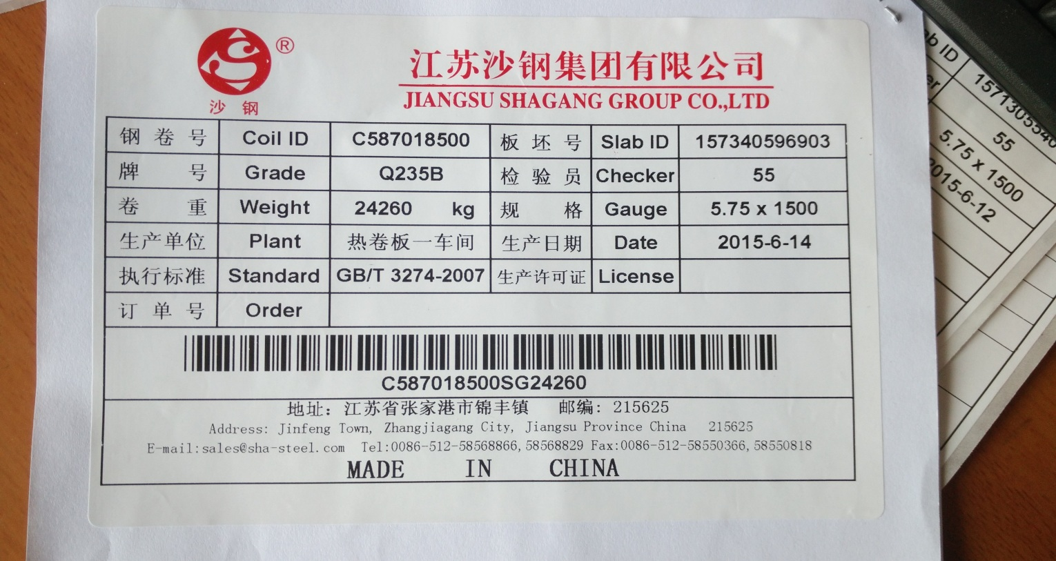

Existing Nameplate of *SHAGANG* Brand Hot Rolled Coil:

