**Appendix**

**New and Existing Surface Logos of YF Brand Hot-rolled Ribbed Bars**

**Existing Surface Logo of YF Brand Hot-rolled Ribbed Bars**

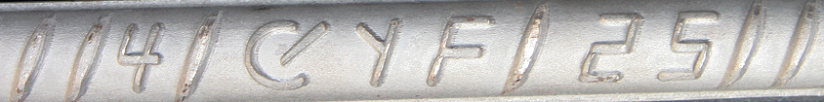

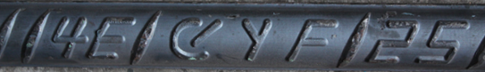

**New Surface Logo of YF Brand Hot-rolled Ribbed Bars**

