Attachment：

The Form of PT. HOK TONG TSR 20 Futures Product Belt Design
Registered Enterprise | Factory Code/Manufacturer (Factory) | Product belt design
PT. HOK TONG | SGO | 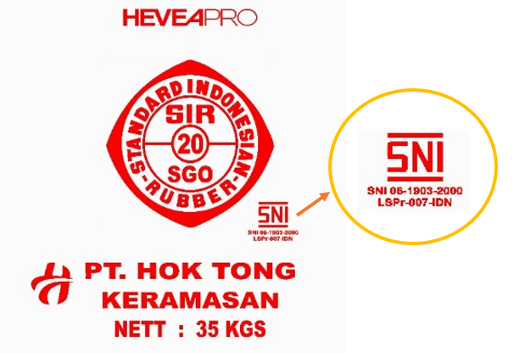 | Old design
PT. HOK TONG | SGO | 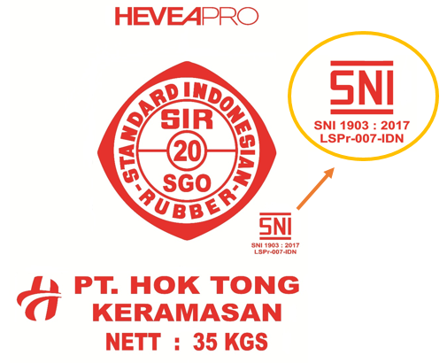 | New design

