Appendix 1
Appendix to Gold Futures Contract of Shanghai Futures Exchange
Note：Words with double strikethrough are deleted and those in red and bold are newly added.
Current Version（August 18,2020） | Revised Version
II. Quality Standards  (2) The chemical composition of domestic gold ingots shall meet the specifications in the following table.Gold content is determined by the subtraction method (i.e., 100% minus the measured impurity levels). The impurities to be measured include but are not limited to the elements listed in the table below:  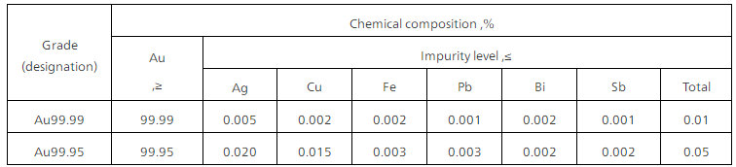  Other properties shall conform to the standards set forth in GB/T 4134-2015. | II. Quality Standards  (2) The chemical composition of domestic gold ingots shall meet the specifications in the following table.Gold content is determined by the subtraction method (i.e., 100% minus the measured impurity levels). The impurities to be measured include but are not limited to the elements listed in the table below:  Other properties shall conform to the standards set forth in GB/T 4134-2015GB/T 4134-2021.

