Appendix：

The New and Current Nameplate and Surface Marker of "Lianfeng" Hot Rolled Ribbed Bars and Hot Rolled Plain Bars

New Nameplate of "Lianfeng" Hot Rolled Ribbed Bars:
The front of new nameplate The back of new nameplate
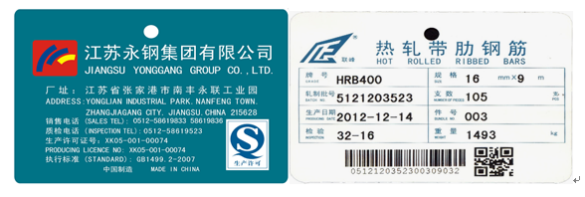
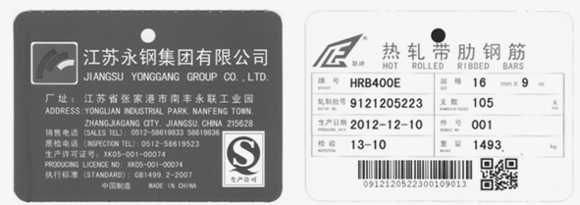

Current Nameplate of "Lianfeng" Hot Rolled Ribbed Bars:
The front of current nameplate The back of current nameplate
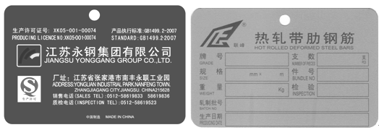

New Surface Maker of "Lianfeng" Hot Rolled Ribbed Bars:
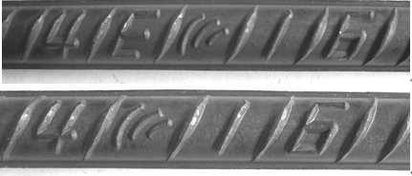

Current Surface Maker of "Lianfeng" Hot Rolled Ribbed Bars:
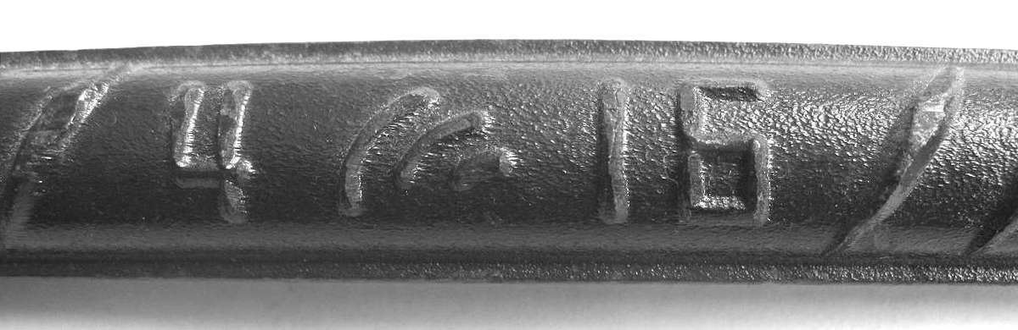

New Nameplate of "Lianfeng" Hot Rolled Plain Bars:
The front of new nameplate The back of new nameplate
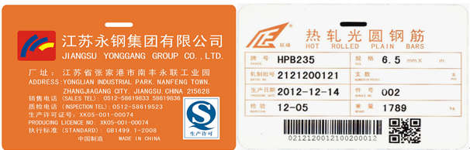
Current Nameplate of "Lianfeng" Hot Rolled Plain Bars:

The front of current nameplate The back of current nameplate
